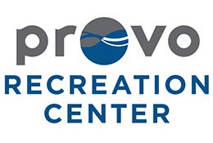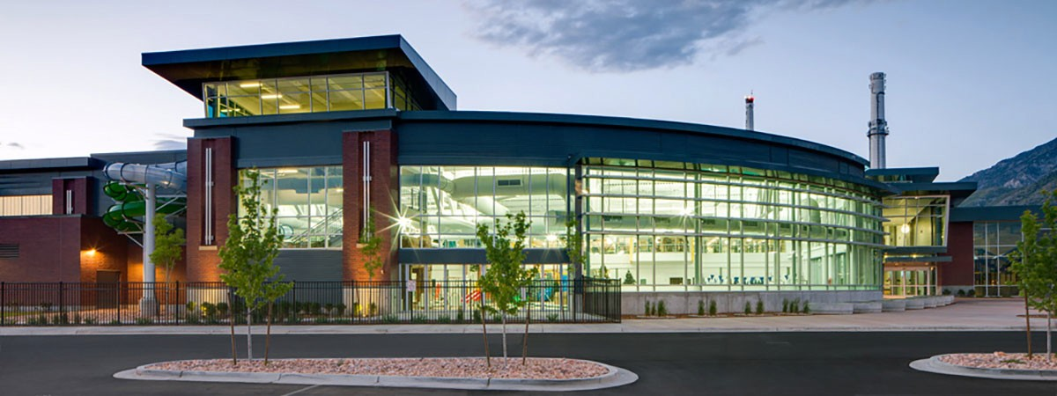

Fitness Center Risk Management Plan

Emma Christensen and Chelsie Johnson

Table of Contents

1. Philosophy/Policy Statements……………………………………………………. 2. Needs Assessment………………………………………………………………... 3. Goals and Objectives………………………………………………………………
4. Site and Facility Development……………………………………………………. 5. Program Development…………………………………………………………….. 6. Supervision…………………………………………………………………………..
- Establishing Safety Rules, Regulations, and Procedures………………………
- Safety Inspections and Investigations…………………………………………….
- Accident Reporting Analysis……………………………………………………….
- Emergency Procedures and Analysis……………………………………………
- Releases, Waivers, and Agreements to Participate……………………………
- Methods of Insuring Against Risk……………………………………………….. 13. In-Service Training………………………………………………………………… 14. Public Relations…………………………………………………………………….
15. Outside Specialist, Legal/Insurance……………………………………………... 16. Periodic Review…………………………………………………………………….

Philosophy/Policy Statement

The Provo Recreation Center is committed to identifying, assessing, controlling, and monitoring all risks that may occur to protect its members, employees, and other affiliates. We pledge our support to using only qualified and highly trained staff to provide the best, most reasonable level of care possible. In the course of operating our business, we are exposed to a variety of risks, including financial, injuries, and accidents within the fitness center.
We have taken a number of steps to reinforce a culture of disciplined risk-taking. Our staff is highly trained to manage and identify potential risks, which provides a pleasurable experience for our guests. Risk management is essential to achieving business goals and maintaining the quality of service provided.

Presently Identified Written Documentation Need Improvement

Will be completed by ( )

Actually completed by ( )

- Philosphy/ Policy
 | X |  | X | X |  | 4/29/16 | 4/14/16
 | X |  | X | X |  | 4/29/16 | 4/25/16
 | X |  | X | X |  | 4/29/16 | 4/14/16
 | X | X |  | X |  | 4/29/16 | 4/25/16
X |  | X |  |  | X
X |  | X |  | X |  | 4/29/16 | 4/25/16
X |  | X |  | X |  | 4/29/16 | 4/21/16
X |  | X |  | X |  | 4/29/16 | 4/26/16
X |  | X |  |  | X
X |  | X |  |  | X
X |  | X |  | X |  | 4/29/16 | 4/26/16
 | X |  | X | X |  | 4/29/16 | 4/24/16
X |  | X |  |  | X
 | X |  | X | X |  | 4/29/16 | 4/24/16
 | X |  | X | X |  | 4/29/16 | 4/24/16
 | X |  | X | X |  | 4/29/16 | 4/26/16

- Needs Assessment
- Goals & Objectives
- Site & Facility Development
- Program Development
- Supervision
- Establishment of Rules, Regulations, Procedures
- Safety Inspections & Investigations
- Accident Reporting Analysis
- Emergency Procedures
- Releases, Waivers, Agreements to Participate
- Methods of Insuring Against Risk
- In-Service Training
- Public Relations
- Outside Specialists, Legal/ Insurance
- Periodic Review
Yes No Yes No Yes No Date Date

Goals and Objectives

  - To create a comprehensive risk-management plan that will specifically target operations within the fitness center.
    - By April 29, 2016, the Provo Recreation Center Risk Management Plan will be ready to be implemented.
    - The risk-management plan will be presented to the entire staff of the fitness center by May 10, 2016.
  - To reduce risk and liability within the fitness center.
    - The risk-management plan will implement various policies and procedures that will reduce liability on Provo Recreation Center accordingly.
    - Potential problems will be identified prior to them occurring in order to protect employees, members, and other affiliates within Provo Recreation Center.
  - To ensure the risk-management plan is implemented correctly, it will be reviewed and updated regularly.
    - The fitness center staff will be presented and informed of the risk- management plan quarterly, beginning May 10, 2016.
    - New employees will be presented and informed of the risk- management plan during their training.
    - The risk-management plan is to be updated in accordance to any federal or state policy change.
    - The risk-management plan is to be updated in accordance to any policy change within the recreation center.

Site and Facility Development

Outside the Recreation Center/ Parking Lot:
- Handicap accessible parking; 20 handicapped parking spaces to 450 parking spaces in the development.
- Handicap accessibility from the parking lot to the front entrance, with automatic opening doors.
- Non-smoking signs posted outside the facility.
- Industrial outdoor mat outside the door to prevent guests from slipping in the facility.

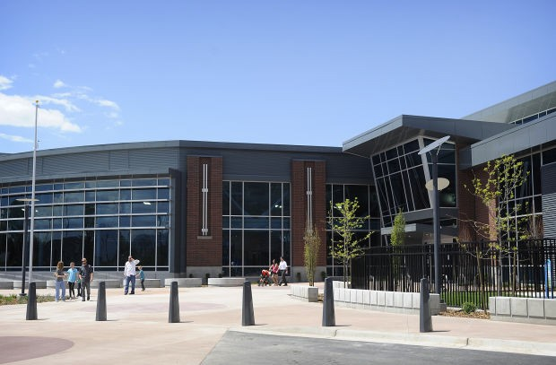

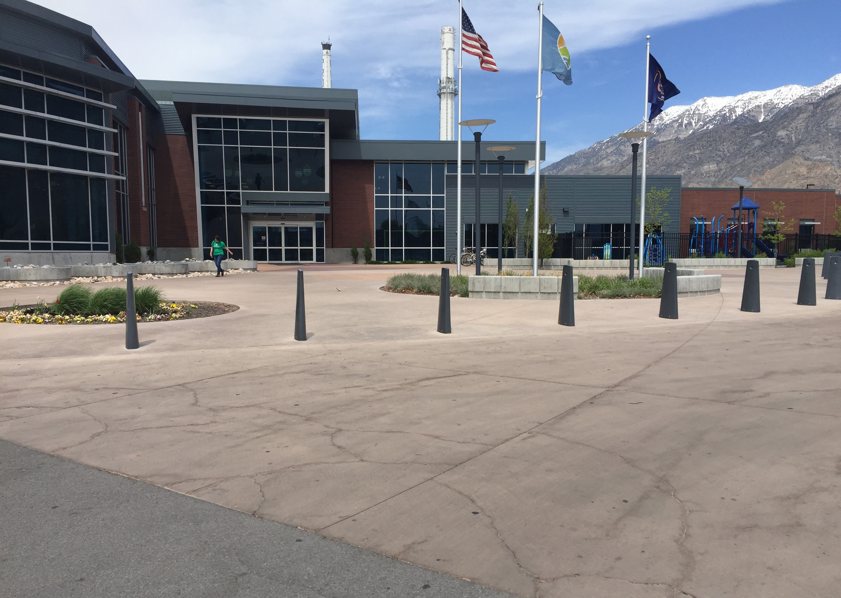

Front Lobby Area:
- Automatic opening doors from the outside into the lobby.
- Tile flooring with an industrial mat for drying shoes to prevent guests from slipping or other accidents.
- Large lobby area to provide accessibility for all guests.
- The front desk is staffed with guest services employees and is wheelchair accessible.
- Entrances to the main facility either through wheelchair accessible entries or a revolving turnstile.
- Exit the main facility through a small gate into the front lobby.
- Industrial mats through each entrance to the main facility.
- Main entrance is also used as an emergency exit.

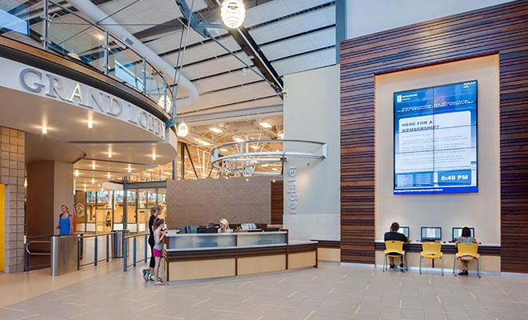

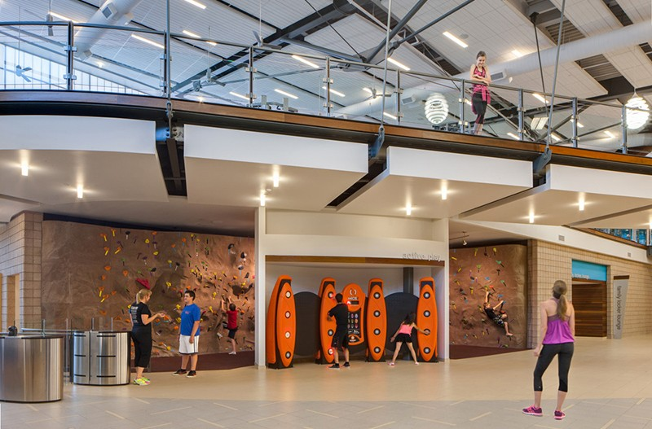

Hallway/Stairs to the Fitness Center:
- Large stairway with railings on each side leading up to the fitness center after entering into the lobby.
- Basketball courts with glass windows from ceiling to the right of the stairs.
- Elevator access near the stairs for wheelchairs, strollers, and people with disabilities.
- Fitness studio passed the elevator and stairs that is wheelchair accessible.
- Emergency exit located on the lower level on the west side, opposite of the lobby.

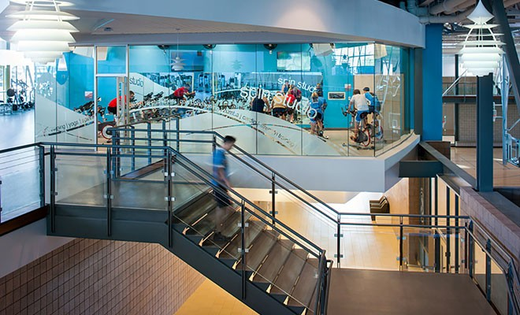

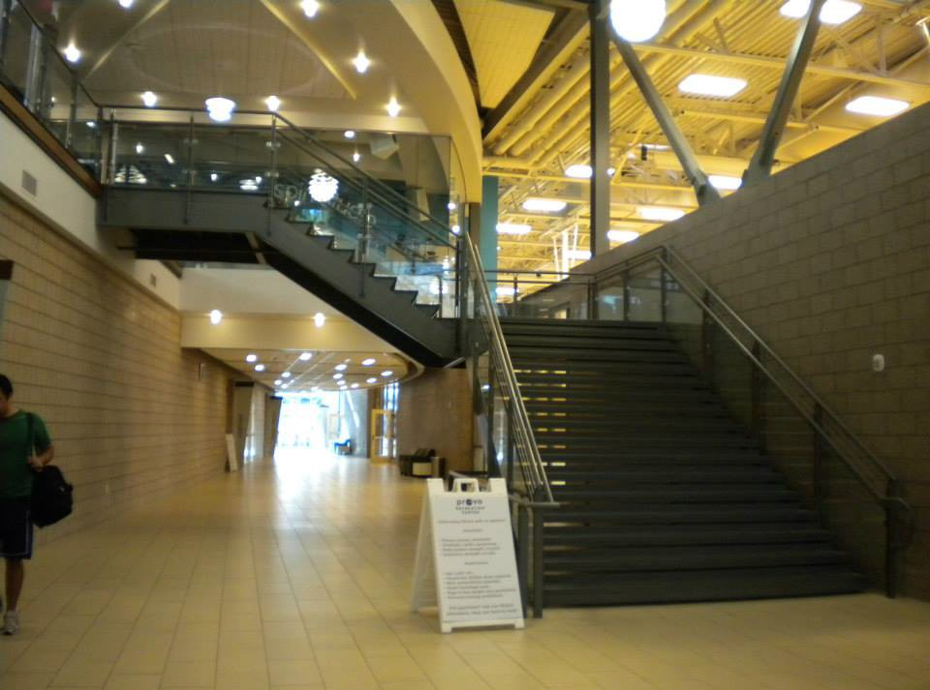

Main Fitness Center Area:
  - Fitness center desk located at the top of the stairs with fitness center guest services employees to provide assistance to guests as needed.
  - Three-foot tall wall surrounding the fitness center creating an upper level tier that looks down to the main lobby, basketball courts, and stairway area.
  - Various types of fitness equipment evenly spaced to allow access for wheelchairs.
  - All fitness equipment is regularly maintained and has the highest level of safety possible according to the type.
  - All fitness equipment is regularly checked and held up to the Fitness Center Safety and Maintenance Checklist. (See checklist under Safety Inspections and Investigations)
  - All rubber mats in the fitness area are secured to the floor, preventing any hazards.
  - The fitness center track runs around the perimeter of the fitness center with lanes clearly marked for walkers and runners.
  - Fitness equipment near the track is given enough space for users to not interfere with runners or walkers on the track.
  - All loose fitness equipment (such as kettlebells, dumbells, medicine balls, etc.) are kept away from the railing to prevent any hazardous situations.

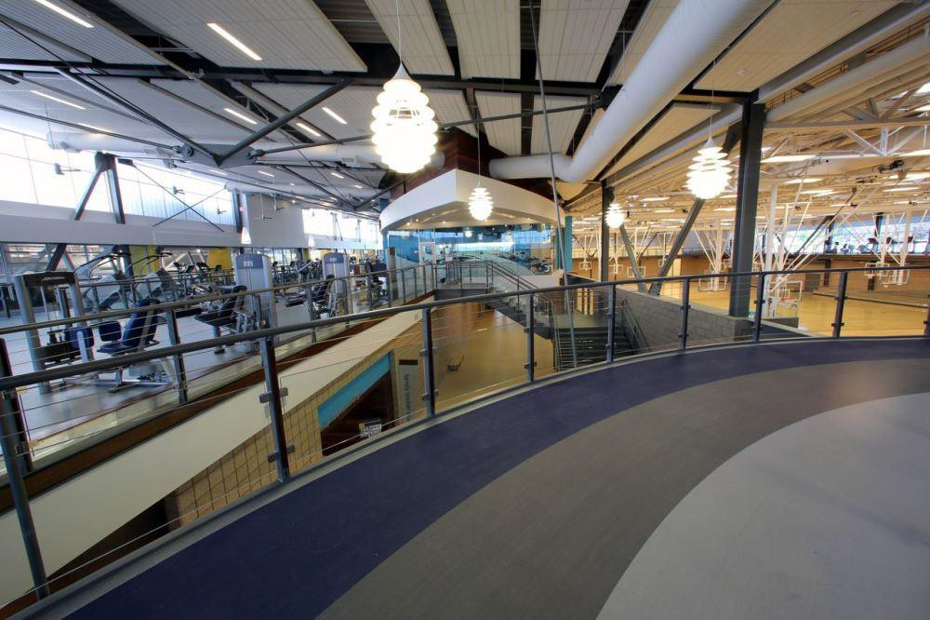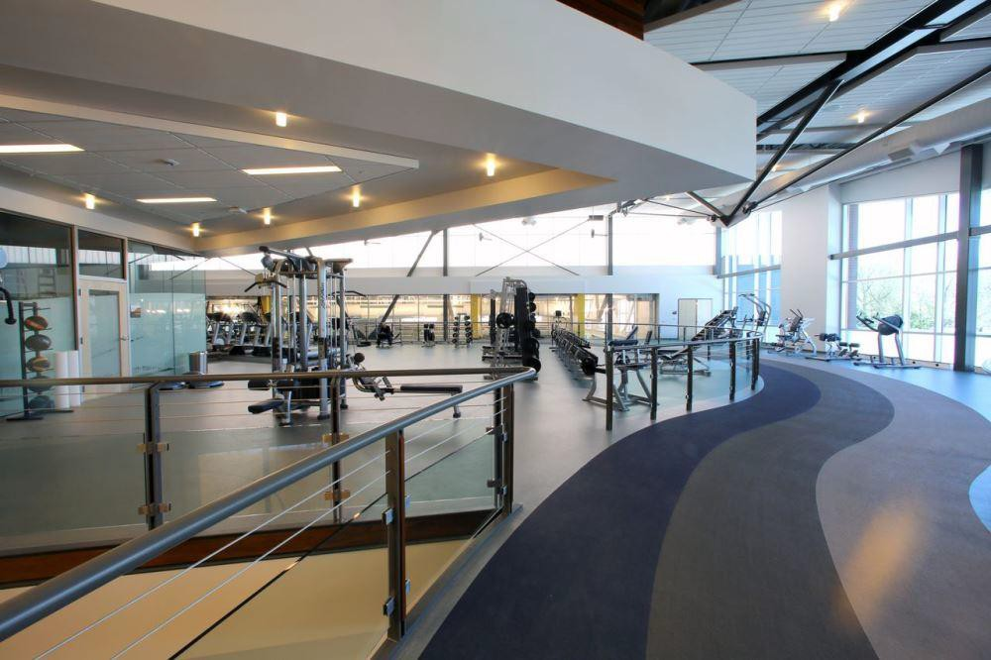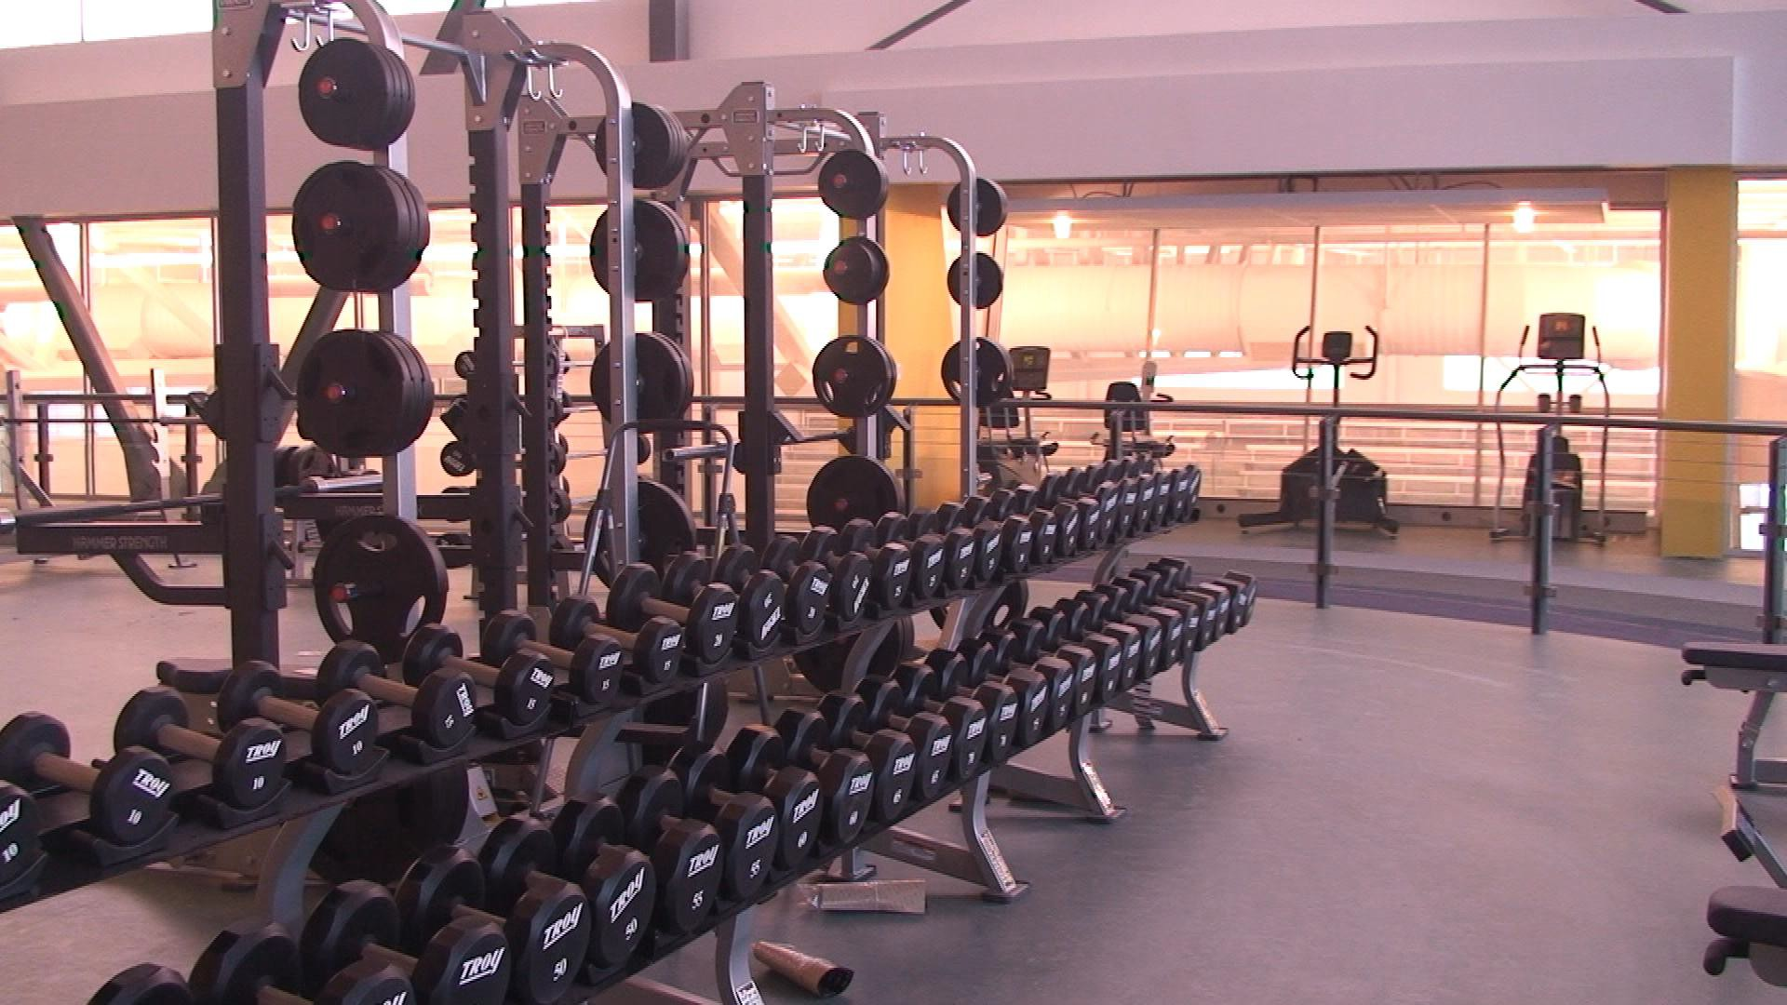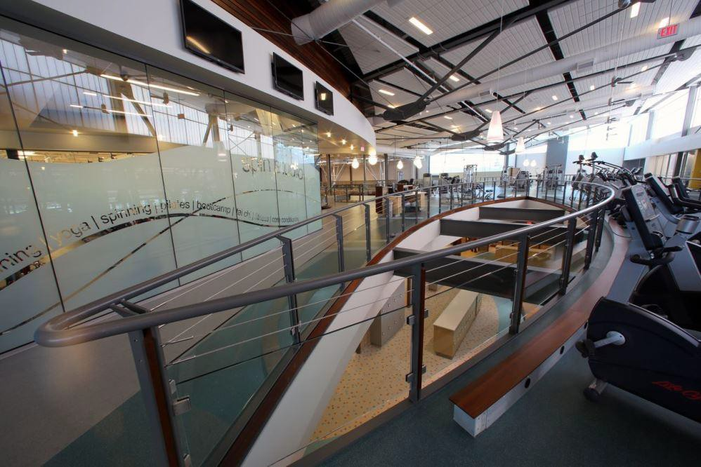

Fitness Class Studios:
- Glass windows surround the upstairs studio, separating the main fitness area from the studio.
- Glass windows surround the downstairs studio, separating the main hallway from the studio.
- Both studios include wooden floors, a ballet bar, a wall of mirrors, two televisions near the ceiling, and stacked chairs to use for certain classes.
- Studios are to be used specifically for fitness classes including yoga, spinning, pilates, and bootcamp.

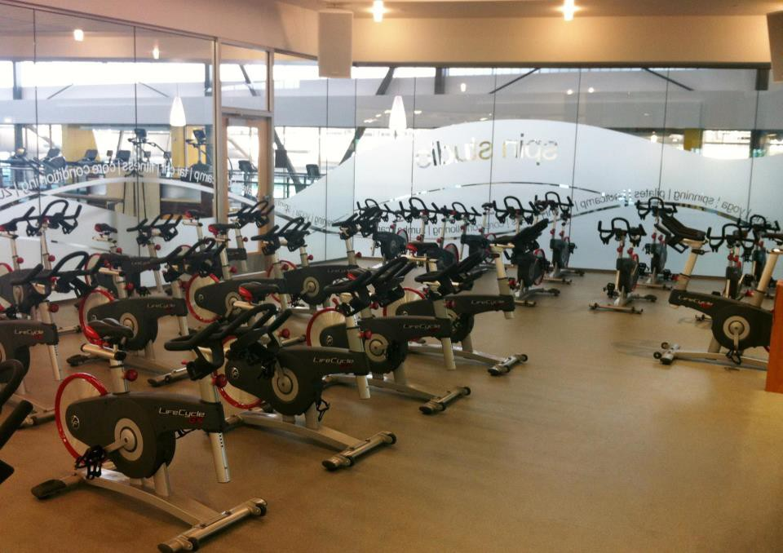

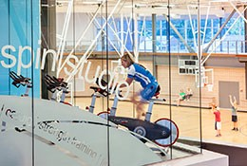

Map of the Provo Recreation Center:

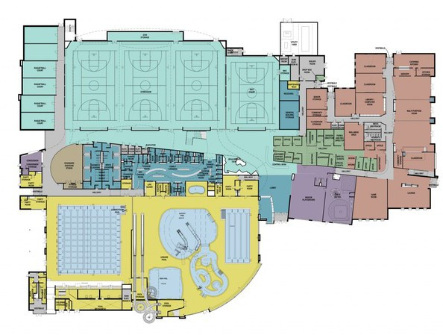

Program Development

CLASS DESCRIPTIONS
FITNESS ADULT CLASSES | DESCRIPTION | INTENSITY | IMPACT
BARRE | Full body sculpting using the ballet barre and small, isometric, concentrated movements. | Medium/High | Medium
BOOT FIT | Want a BOOT CAMP circuit? A training circuit designed to shed fat FAST! Entirely focused on burning fat and jumping your metabolism through the roof for hours! | Medium/High | Medium
CYCLE | The ultimate workout for athletes as well as the couch potatoes looking to get in the best shape of their lives. You will want water and towel for this one for sure! | Medium/High | Low
FLOOR IT! | New to the rec and need some workout or nutrition tips? Or just looking for a weekly workout you can do on our fitness floor? A new program to give you a weekly plan for attacking upper body, lower body, core, and cardio. | Medium | Low
INSANITY | Traditional interval training flipped on its head! Alternate between aerobic and anaerobic intervals. The result: burn up to 1,000 calories in an hour! | Medium/High | Medium/High
KICK IT! | The Karate Kid in our recreation center, minus the hike along the Wall of China. Jab left and right, cross punch your arch enemy, and kick your way to high energy combat! | Medium/High | Medium/High
PILATES | Find your body’s center. You probably didn’t know you had one?! Build strength and conditioning with balanced movements. | Medium/High | Low
PILOXING | Blend power, speed, and agility of boxing with the targeted sculpting and flexibility of pilates. Add to that dance moves and you have a muscle- toning, fat-burning workout that will make you feel physically empowered! | Medium/High | Low
PiYO | Pilates and yoga that burns calories while transforming the body. Relax & Stretch? No thanks, we’d rather burn. | Medium/High | Low
RIP | Looking for the chiseled and toning effect? This class uses free weights, resistance bands, barbells, steps, body weight, and plyometrics to tone and tighten everywhere. Make sure you check out our app for more detailed descriptions on what you can expect from the instructor! | Medium/High | Medium
SILVER SNEAKERS | Muscular strength, balance, and range of motion for seniors, or those recovering from injury. Use a chair to ease yourself into regular classes and improve your heath! | Low | Low
U-JAM | Love Hip Hop? This one is a must! Learn how to bust moves that will make Justin Timberlake and Michael Jackson fall over, AND burn calories?! Who could ask for more? | Medium/High | Low/Medium
YOGA | Can you remember the last time you focused on your breathing and relaxation? That’s what we thought. Ease the stress of your day by using dynamic breathing and strong flowing movements for greater strength, flexibility, and range of motion. Make sure you check out our app for more detailed descriptions on what you can expect from the instructor! | Low/Medium | Low
ZUMBA | Did anyone say party? Latin-American dance class with creative patterns and fresher music than the last order of chips and salsa you ate. Like dance? This is a must! Make sure you check out our app for more detailed descriptions on what you can expect from different formats. Formats include: Gold, Sentao, and Toning! | Medium/High | Low/Medium

FITNESS YOUTH CLASSES | DESCRIPTION | INTENSITY | IMPACT
ZUMBA (Ages 4-14) | Bust a ridiculous dance move in front of your friends or watch TV on the couch? We think there is an obvious answer here. | Medium/High | Low
YOGA (Ages 4-14) | Practice fun and challenging poses, learn how to focus and center your energy, and breathe like you never have before. Come join the fun! | Medium/High | Low

AQUA ADULT CLASSES | DESCRIPTION | INTENSITY | IMPACT
AQUA ZUMBA | This class is fun and invigorating with Latin American/international rhythms and dance designed for aqua fitness. The decreased force of gravity  enables you to get a workout without stressing the joints and back, but will give you the aerobics to promote muscle flexibility and joint mobility. You will also be burning the same amount of calories, while your heart does not work as hard. Come and join the Zumba pool party experience! This class is great for every age and fitness level. Non-swimmers welcome! | Medium | Low
AQUA NINJAS | This fast paced workout is designed to be a step higher than the average water aerobics class. This class will challenge your movements and work your cardiovascular system while increasing strength, balance, power and range of motion. This class combines segments of cardio and strength training using training intervals. Flotation equipment provided. Non-swimmers welcome however must be comfortable in deep water. | Medium | Low
DEEP WATER CHALLENGE | This high-intensity class is designed for those who wish to obtain a full cardiovascular workout, while using the natural resistance of the water to  help increase strength, power, flexibility, endurance and range of motion. Suspension in deep water helps create a challenging aerobic interval workout using adaptations of jogging, cross country skiing, bicycling, and kicking exercises. Flotation equipment provided. Non-swimmers welcome however must be comfortable in deep water. | Medium | Low
SENIOR WATER AEROBICS | This class provides a low-intensity, low-impact workout with a number of different movements aimed at increasing flexibility, balance, strength and cardiovascular fitness. The class also utilizes barbells, buoyancy equipment and resistance equipment for a rewarding aerobic workout. An excellent class for older adults and beginners. Non-swimmers welcome! | Medium | Low
SHALLOW WATER AEROBICS | This shallow water workout includes calisthenics style movements with variations of upper and lower body resistance moves. You will march,  jog, kick, and jump your way through the water to improve and maintain cardiovascular fitness, muscular endurance and flexibility. As the participant, you determine your own intensity by deciding how hard to manipulate the water. The class also utilizes barbells, buoyancy equipment and resistance equipment for a rewarding aerobic workout. Non-swimmers welcome! | Medium | Low

FITNESS WINTER SCHEDULE - updated 1/21/16
Winter 2016 Classes are for 14+ unless otherwise noted

 | MONDAY | TUESDAY |  | WEDNESDAY |  | THURSDAY |  | FRIDAY | SATURDAY
 | PROGRAM STUDIO | PROGRAM STUDIO | BULLDOG COURT | PROGRAM STUDIO | BULLDOG COURT | PROGRAM STUDIO | BULLDOG COURT | PROGRAM STUDIO | PROGRAM STUDIO
6:00AM | RIP  Amy T | YOGA  Karen |  | ZUMBA  Alisa |  | PILATES  Heather |  | ZUMBA SENTAO  Alisa
8:00AM | YOGA  Molly | RIP  TawnyR |  | YOGA  Delene |  | RIP  TawnyR |  | BARRE  Christy | PIYO  Brynne
9:00AM | YOGA  Heather | ZUMBA KIDS JR  (ages 4-7) Jamee, Kim Y |  | YOGA  Nichole |  | U-JAM  Ashley |  | U-JAM  Nicole | BARRE  Alicia
10:00AM | ZUMBA GOLD  Colleen | PILATES  Amy S |  | ZUMBA GOLD  Colleen | YOGA KIDS  (ages 4-7) Kate, Felisha | PILATES  Amy S |  | ZUMBA GOLD  Jamee | YOGA  Amy D
11:00AM |  | SILVER SNEAKERS  Alice |  |  |  | SILVER SNEAKERS  Alice |  | SILVER SNEAKERS YOGA  Alice | ZUMBA KIDS JR  (ages 4-7) Tui, Alisa
12:00PM | BARRE  Alicia |  |  | BARRE  Alicia
4:00PM |  | ZUMBA KIDS JR  (ages 4-7) Lindsay, Jamee | ZUMBA KIDS  (ages 8-14) Alisa, Jen |  |  | ZUMBA KIDS JR  (ages 4-7) Lindsay, Kim Y | ZUMBA KIDS  (ages 8-14) Alisa, Stacey
5:00PM | RIP  Amy D | BARRE  Lindsay |  | RIP  Amy DIPnon
6:00PM | U-Jam Kim | P90X  Felisha |  | U-JAM  Ashely
7:00PM |  | BOOT FIT  Bill |  |  |  | ZUMBA TONING/ SENTAO  Alisa
8:00PM | YOGA  Karen | ZUMBA  Triana |  | YOGA  Karen |  | ZUMBA  Triana

Check out our latest schedule changes with the APP! APP: PROVO RECREATION CENTER
ONLINE: mindbodyonline.com

*No regularly schedules fitness classes will be held on the following days: January 18, February 15, May 30

FITNESS WINTER SCHEDULE - UPSTAIRS
Classes are for 14+ unless otherwise noted

 | MONDAY |  |  | TUESDAY |  | WEDNESDAY |  |  | THURSDAY |  | FRIDAY |  | SATURDAY
 | FITNESS STUDIO | SPIN STUDIO | SYNERGY 360 | FITNESS STUDIO | SPIN STUDIO | FITNESS STUDIO | SPIN STUDIO | SYNERGY 360 | FITNESS STUDIO | SPIN STUDIO | FITNESS STUDIO | SPIN STUDIO | FITNESS STUDIO | SPIN STUDIO
5:00AM | RIP  Tawny |  |  | RIP  Amy T |  |  |  |  | RIP  Amy T
6:00AM | ZUMBA TONING  Alisa | CYCLE  Amy W | BOOT FIT TRX  Lauren, Gary | RIP  Amy T | CYCLE  Andrea | RIP  Amy W | CYCLE  Brittany | BOOT FIT TRX  Lauren, Gary | RIP  Amy T | CYCLE  Andrea | RIP  Kara | CYCLE  Amy W | RIP  Amy T
7:00AM |  |  |  |  |  |  |  |  |  |  |  |  | ZUMBA TONING  Alisa | CYCLE  Maggie
8:00AM | RIP  Julie |  |  | YOGA  Amanda |  | RIP  Julie |  |  | YOGA  Amanda |  | RIP  Julie |  | RIP  Lauren
9:00AM | ZUMBA  Michelle | CYCLE  Marin |  | RIP  Amy S | CYCLE  Brittany | ZUMBA  Michelle | CYCLE  Lauren |  | KICK IT  Amy S | CYCLE  Amanda A | PILOXING  Christy | CYCLE  Marin | ZUMBA STEP  Lindsay
10:00AM | RIP  Michelle |  |  | ZUMBA  Triana |  | PILATES  Michelle |  |  | RIP  Kara |  | YOGA  Delene |  | INSANITY  Shelby
11:00AM | ADAPTIVE YOGA  Kate |  |  |  |  | ADAPTIVE YOGA  Kate |  |  |  |  | ZUMBA  Triana
5:00PM | YOGA  Shawn |  |  |  |  | YOGA  Shawn
6:00PM | INSANITY  Chad | CYCLE  Maggie |  | YOGA  Karen | CYCLE  Drew | P90X  Felisha |  |  | YOGA  Paige | CYCLE  Drew
7:00PM | ZUMBA  Nino, Betzabe |  | BOOT FIT TRX  Bill | KICK IT  Brynne |  | ZUMBA  Kim Y, Betzabe |  | BOOT FIT TRX  Bill | BOOT FIT  Bill
8:00PM | ZUMBA  Colleen |  |  | RIP  Drew |  | ZUMBA  Colleen |  |  | INSANITY  Felisha
9:00PM |  |  |  | PIYO  Maria |  | ZUMBA STEP  Lindsay |  |  | PIYO  Felisha

Supervision

Recreation
Director
Recreation Center
Manager
Fitness Center
Supervisor
Fitness Program
Coordinator
Community
Programs/ Events Supervisor
Maintenance
Technician
Fitness Center
Guest Services
Fitness Instructors
Personal Trainers
Community
Programs Coordinator

Ratio of Employees to Customers:

During business hours, there shall always be at least one CPR trained fitness center employee on the floor at all times. The fitness center should never be left unattended by the staff. For every 10 customers utilizing the fitness center, there should be an additional two staff members in the fitness center area.
During fitness classes, there shall always be at least one trained fitness instructor in the studio at all times. Staff members who are not trained to teach fitness classes should not be in the studio during class times. The fitness studios are to be locked and closed when they are not in use by staff members permitted to be in the studio.

Job Description

Job Title: Fitness Director | Department: Fitness
Reports To: General Manager | Status: Exempt

JOB SUMMARY
The Fitness Director is responsible for the group exercise and personal training departments. He/she oversees both departments and leads the staff to provide a sustainable level of excellence in character, customer service and execution of job duties.

ESSENTIAL DUTIES AND RESPONSIBILITIES
- Manages the group exercise and personal training teams (including: hiring, firing, payroll and performance management issues)
- Trains new employees and provides ongoing training for all group exercise and personal training staff
- Coordinates the group exercise schedule and instructors
- Establishes, monitors and analyzes the group exercise and personal training budgets
- Develops and implements policies and procedures for the department
- Conducts departmental meetings
- Acts as contact person for members regarding group exercise and personal training matters
- Supervises any specialized fitness program in the department (i.e. Women on Weights, Ski Conditioning, Teens in Training, etc.)
- Evaluates program effectiveness and success based on revenues, participation, satisfaction and further interest
- Responsible for zone management duties which include reporting any facility, janitorial, or capital improvement needs for assigned area
- Other duties as assigned

REQUIRED KNOWLEDGE, SKILLS AND ABILITIES
- Excellent communication and interpersonal skills
- Excellent customer service skills
- Good management skills
- A comprehensive understanding of the fitness industry

REQUIRED EDUCATION, CERTIFICATIONS AND EXPERIENCE
- Experience in a health club or the hospitability industry is preferred
- College degree preferred
- CPR, First Aid, and AED certifications (must be obtained within 60 days of hire)

Job Description

Position: SITE Program Coordinator Category: Full-Time, Salaried Exempt Supervisor:
Salary: $
Start Date:

Job Components

- Develop and implement programs for client company’s employees: including researching the topic area, benchmarking with other sites, interviewing potential staff/instructors, creating advertisements (mass e-mails, fliers, web page, newsletter articles, bulletin boards), forecasting budgets, setting participation/financial goals, assigning task/training coworkers if needed, scheduling conference rooms and equipment, negotiating fees, establishing contracts, on-line registration development/implementation, web page updating, sending/responding to mass e-mails, overseeing flier production/distribution process, e-mailing reminders to registered participants, oral/written communication with hired staff/instructors.
- Evaluate the programs including on-line survey development, web page updating, e-mailing participants, responding to surveys, compiling survey results, analyze and report statistical and quantitative information weekly, completing program/budget recap report, submitting payment for hired staff/instructors.
- Assist with all fitness center programming.
- Continually enhance fitness center appearance through bulletin boards, fliers and web pages.
- Assist with the supervision of the fitness center, staff, operations and programs.
- Perform facility and equipment maintenance processes.

Job Requirements

- College degree in Corporate Wellness, Kinesiology, Recreation, or related field.
- 1-2 years experience in corporate wellness management or commercial fitness center management.
- Professional certification (ACSM, ACE, or similar)
- CPR and First Aid Certification.
- 1-2 years wellness program development and implementation experience.
- Professional and enthusiastic attitude.
- Ability to problem-solve, and make key decisions.
- Excellent written and verbal communication skills and organizational skills.
- Proven ability to provide high quality customer service.
- Proven ability to work independently.
- Proficiency with industry standard word processing, spreadsheet, database, graphics, and presentation applications.
- Ability to multi-task, works independently and with a team, and performs detail-oriented functions.

This job description is not intended to be all-inclusive. It is understood that the employee will also perform reasonable, related duties if requested by immediate supervisor or other management staff.

Employee Signature/Date Supervisor Signature/Date

Fitness Supervisor Job Summary
To support the Fitness Manager in the effective supervision of the facilities on a day-to-day basis. To provide the highest standards of customer service and safety at all times in accordance with the policies, procedures and systems. Ensuring staff are motivated and well supervised to deliver the required standards. To deliver initiatives in the marketing promotional plan for the fitness facility.

Essential Duties and Responsibilities
  - To supervise and develop the use of gym resources under Fitness Supervisor control, in liaison with the Fitness Manager, paying particular attention to staff supervisory management, individual development and safety requirements.
  - To instruct fitness sessions, as and when required, at various levels of ability on both a group
  - and individual basis. To assist users with exercise enquiries, general training, compilation of
  - personalized programmers and supervise timetabled classes.
  - To co-ordinate courses operated within the Gym from school to group bookings. To ensure
  - that provision is made through rota planning, registers and invoicing.
  - To coordinate the spinning programme and ensure that cover for classes is provided along
  - with excellent communication with customers and instructors.
  - To monitor the LUS (lower user system) on customers and take the necessary actions
  - through staff to improve customer usage.
  - To assist in meeting income targets for the fitness facility, in line with the Centre
  - expectations.

Supervisor Requirements:
  - Complete thorough training of the Wellness Center office duties and responsibilities.

Recreation Center Manager Job Summary
Management level employees are responsible for managing CRW programs and working with multiple program areas within the department. They supervise staff from all CRW program areas
and assist in the hiring, training, and evaluation of all staff. Managers are highly involved in many programs and facility maintenance aspects of CRW. Managers are expected to collaborate
with staff from all CRW program areas and several other departments on and off campus.

Essential Duties and Responsibilities:
  - Carry out daily tasks and functions assigned by the Coordinator
  - Develop and update Wellness Center event statistics
  - Oversee Wellness Center student staff
  - Train Wellness Center student staff on current rules and regulations
  - Help the Coordinator complete current scheduling of student staff
  - Manage current Wellness Center inventory
  - Assign daily tasks and duties to Wellness Center student staff
  - Assist in the ordering of equipment and supplies
  - Assist the Coordinator in maintaining the Wellness Center Policies and Procedures Manual
  - Schedule student staff and oversee Wellness Center events
  - Help in the development of our personal training program
  - Assist with the implementation of the group exercise instructor training program
  - Communicate any problem, member concerns or suggestions to the Coordinator of Fitness
  - and Wellness or the CRW Director
Qualifications and training required
Employers may prefer graduates with qualifications in sports science, recreation/leisure studies, health management, physiology, life sciences, business or management. A relevant postgraduate qualification (for example an MSc in sports science) can be useful, particularly for graduates without appropriate first degrees. Related work experience is normally necessary. This can be gained via part-time or seasonal work as a coach, fitness instructor, recreation assistant or leisure/fitness center attendant.
Required skills and Abilities
Candidates must be physically fit and should possess sound customer service, business, management, sales and marketing skills. Good problem solving, interpersonal, organizational and communication skills are also essential. First aid qualifications are beneficial for most positions.

Recreation Director Job Summary
Under general supervision from the Public Services Director, performs administrative, supervisory and professional work in the planning, development and operation of a comprehensive public recreation program for the community.

Essential Duties and Responsibilities
  - Plans and manages a comprehensive citywide recreation program including athletic
  - leagues, instructional programs, day camps, and special events.
  - Manages the Community Center and programs therein; including staffing, maintenance,
  - and marketing.
  - Trains, supervises and evaluates work performance of full-time and seasonal personnel;
  - makes recommendations for hiring and termination; prepares schedules and assignments
  - for recreation personnel.
  - Provides for risk management practices; ensures all safety rules, regulations and
  - procedures are followed; makes sure that employees are trained in safety procedures.
  - Prepares and manages annual budget for recreation program functions. Approves
  - purchases of supplies and operating inventory for recreation programs. Develops
  - alternative funding sources for programs and improvements.
  - Performs public relation duties; responds to complaints; handles all league suspensions
  - and rule enforcement; prepares news releases, information and marketing bulletins or
  - other publicity on recreation activities; identify and meet the recreational needs of diverse

Required Education, Certifications and Experience
  - Bachelors Degree in recreation administration, physical education, or a closely related
  - field and four (4) years of experience in supervising recreation programs, or any
  - equivalent combination of education and experience.
  - Special Requirements
  - Must be bondable; valid Utah Driver's License required.
  - Necessary Knowledge, Skills and Abilities
  - Working knowledge of recreation programs and their management; working knowledge
  - of the rules of a variety of sports; working knowledge of modern office and bookkeeping
  - procedures.
  - Skill in operating a variety of office equipment; PC experience a plus.
  - Ability to participate in active sports and recreation activities; ability to organize and
  - direct programs; ability to work night shifts; ability to work weekends; ability to establish
  - and maintain effective working relationships with employees, other agencies and the
  - public; ability to follow written and oral instructions; ability to communicate effectively,
  - verbally and in writing.

Fitness Instructor Job Summary
Employee is responsible for teaching Jazzercise at the Corporate Club. Employee is also available to cover front desk hours and substitute as a Cardio Kickboxing instructor when needed.

Required Knowledge, Skills, and abilities

- 2-3 Years Teaching Experience in Corporate or Commercial Wellness Setting
- Professional Certification (ACE, ACSM, or other)
- Proven ability to provide high quality customer service
- Professional, enthusiastic attitude, team player

Job Components

- Teach Jazzercise at Club
- Substitute other fitness classes when needed
- Cover front desk when needed

Personal Trainer Job Summary
The Personal Trainer’s purpose is to build a client base that contributes to departmental revenues by maintaining an existing client base, marketing programs and services, and utilizing the highest quality of customer service.

Essential Duties and Responsibilities
- Maintain a personal commitment to meeting the needs of members and guests.
- Demonstrate correct use of all weight and cardiovascular equipment.
- Conduct client interviews and counsel members on exercise recommendations based on fitness evaluations as well as members’ needs and goals.
- Conduct a minimum of 25 personal training sessions per week (average) after 120 days of employment.
- Assist in development and implementation of club programs and events.
- Participate in all staff related meetings and other required activities.
- Behave as a role model by leading and promoting a healthy lifestyle.
- Maintain a positive attitude at all times when working with members.
- Seek opportunities for personal and professional growth.
- Dress professionally, according to the current dress code standards.
- Perform a customer service role by assisting members in monitoring their exercise programs, encouraging members to reach their fitness and wellness goals, and handling member concerns and complaints quickly and effectively.
- Actively market and promote personal training to acquire new members and retain existing members.
- Encourage members to take advantage of other club services and programs.
- Recommend changes for programming and services in line with current market trends.
- Other duties as assigned

Requires knowledge, Skills, and Abilities
- Must be able to manage time effectively.
- Must be able to market personal training and obtain clients.

Required Education, Certifications, and Experience
- Must have a minimum of two years of education in the field of exercise science or a related field and at least two years experience in a similar position; or a Bachelor’s degree in exercise science or a combination of education and experience
- Nationally recognized personal training certification from NSCA or ACSM preferred. Other certifying bodies will be considered.
- Must have current CPR, First Aid, and AED certifications (must be obtained within 60 days of hire)

Physical Demands
- Must be able to physically or verbally demonstrate proper usage of equipment. While performing duties of this job, the employee is regularly required to use hands to finger, handle, or feel; reach with arms and hands; and hear or talk. The employee is occasionally required to
stand, walk, climb, balance, stoop, kneel, crouch, or crawl.

Maintenance Technician Job Summary
The Maintenance Person is responsible for maintaining and repairing equipment, building issues, pools, etc.

Essential Duties and Responsibilities
- Maintains and repairs equipment
- Responsible for building and pool issues
- Follows schedule/checklist as closely as possible, but stays flexible to variances
- Records on schedule the times tasks are completed
- Cleans, dusts, mops, etc.
- Takes ownership of areas of responsibility
- Responsible for cleaning up areas worked in and equipment used
- Attends department meetings as scheduled
- Other duties as assigned

Required Knowledge, Skills, and Abilities
- Creative and inventive in developing ways to make job more efficient
- Must be able to work independently
- Must be punctual, thorough and have a great work ethic

Required Education, Certifications, and Experience
- Experience in cleaning is helpful
- CPR, First Aid, and AED certifications (must be obtained within 90 days of hire)

Front Desk Attendant Job Summary
The Front Desk Attendant is the lead customer service contact for all members, guests, or prospects. The Front Desk attendant is also responsible for selling all products and services.

Essential Duties and Responsibilities

- Greets and checks in all members and guests
- Sells all products and services
- Liaison between members and Membership Office: Including prospects and current members
- Schedules for both Skin Care and Massage Offices
- Answers and directs all incoming phone calls
- Fields all member complaints and concerns
- Performs Opening and Closing Procedures for the club if assigned those shifts
- Responsible for keeping both Program and Check-In desks clean, neat, and orderly
- Attends monthly departmental meetings
- Maintains professionalism when not assisting members; avoids eating, sitting, reading, Internet surfing, or any other activities that are not work-related
- Creates the “First Impression”
- Other duties as assigned

Requires Knowledge, Skills, and Abilities
- Must be highly motivated and energetic
- Excellent communication and interpersonal skills
- Organizational skills
- Strong attention to detail
- Ability to multi-task
- An understanding of health club operations
- Must be a team player, willing to cover or trade shifts when necessary
- Must be able to work days, evenings, and weekends as necessary

Requires Education, Certifications, and Experience
- Must have experience in customer service
- Experience in health club or the hospitability industry is preferred
- CPR, First Aid, and AED certifications (must be obtained within 60 days of hire)

Community Program Coordinator Job Summary

- Develop and implement programs for client company’s employees: including researching the topic area, benchmarking with other sites, interviewing potential staff/instructors, creating advertisements (mass e-mails, fliers, web page, newsletter articles, bulletin boards), forecasting budgets, setting participation/financial goals, assigning task/training coworkers if needed, scheduling conference rooms and equipment, negotiating fees, establishing contracts, on-line registration development/implementation, web page updating, sending/responding to mass e-mails, overseeing flier production/distribution process, e-mailing reminders to registered participants, oral/written communication with hired staff/instructors.
- Evaluate the programs including on-line survey development, web page updating, e-mailing participants, responding to surveys, compiling survey results, analyze and report statistical and quantitative information weekly, completing program/budget recap report, submitting payment for hired staff/instructors.
- Assist with all fitness center programming.
- Continually enhance fitness center appearance through bulletin boards, fliers and web pages.
- Assist with the supervision of the fitness center, staff, operations and programs.
- Perform facility and equipment maintenance processes.

Job Requirements
- College degree in Corporate Wellness, Kinesiology, Recreation, or related field.
- 1-2 year’s experience in corporate wellness management or commercial fitness center management.
- Professional certification (ACSM, ACE, or similar)
- CPR and First Aid Certification.
- 1-2 years wellness program development and implementation experience.
- Professional and enthusiastic attitude.
- Ability to problem-solve, and make key decisions.
- Excellent written and verbal communication skills and organizational skills.
- Proven ability to provide high quality customer service.
- Proven ability to work independently.
- Proficiency with industry standard word processing, spreadsheet, database, graphics, and presentation applications.
- Ability to multi-task, works independently and with a team, and performs detail-oriented functions.

Confidential Employee Performance Form

Employee Name:

Job Title:

Reviewer: Review Date:
Job Performance
Evaluation Item | Rating
1. General Quality of Work | 5 | 4 | 3 | 2 | 1
2. Dependability | 5 | 4 | 3 | 2 | 1
3. Job Knowledge | 5 | 4 | 3 | 2 | 1
4. Communication Skills | 5 | 4 | 3 | 2 | 1
5. Personality | 5 | 4 | 3 | 2 | 1
6. Customer Service Skills | 5 | 4 | 3 | 2 | 1
7. Management Ability | 5 | 4 | 3 | 2 | 1
8. Productivity | 5 | 4 | 3 | 2 | 1
9. Achievement of Goals | 5 | 4 | 3 | 2 | 1
10. Other: | 5 | 4 | 3 | 2 | 1

5 | Excellent
4 | Very Good
3 | Good
2 | Fair
1 | Poor

Performance Summary
What are the employee’s strongest points?

What are the employee’s weakest points?

What can the employee do to be more effective or make improvements?

What additional training would benefit the employee?

Employee Feedback
What are your most important accomplishments over the past year?

What are your weakest areas and how could you improve?

What are your supervisor’s strength’s and weaknesses?

Other concerns you would like to discuss:

Provo Recreation Center Guest Service & Aquatic Staff Audit

Shift Lead Name (first and last) Full Time Staff Performing Audit
Time, & Date
PROFESSIONALISM
Was the staff forward facing patrons? | Yes | No | N/A
Was the staff properly dressed (no jeans, business casual + shirt, fitness professional upstairs)? | Yes | No | N/A
Did staff greet incoming patrons before reaching the desk (10ft)? | Yes | No | N/A
Did staff acknowledge exiting patrons? | Yes | No | N/A
Did staff look up from monitors at patrons regularly? | Yes | No | N/A
Are all staff engaged in helping patrons or proactively finding other tasks? | Yes | No | N/A
Comments
OPERATIONS AND CONTROLS
Are all lights & TVs functional? Signs properly pulled into hallways for display? Music on? | Yes | No | N/A
Is guest service staff properly distributed and assigned to handle lines, registration, control, etc? | Yes | No | N/A
Are Station 1 & 2 helping if not on the phone? | Yes | No | N/A
Are the member monitor and gate working properly? | Yes | No | N/A
Is the shift lead consistently available/present to the front desk staff? | Yes | No | N/A
Were all patrons stopped for payment or program/sport check in through lane 1? | Yes | No | N/A
Are sliding doors on tracks and set to auto? | Yes | No | N/A
Is the desk area clear of large groups of patrons? | Yes | No | N/A
Were the locker rooms & bathrooms regularly checked by staff? | Yes | No | N/A
Comments
APPEARANCE
Are the desk & work stations clean and free of visible food and drink? | Yes | No | N/A
Are the desk & work station clutter free, organized, and free of papers with sensitive information? | Yes | No | N/A
Is the signage straight and applicable (no expired dates, etc)? | Yes | No | N/A
Is there desk area free of standing water or other hazards? | Yes | No | N/A
Is the front sitting area free of outside food and drink? | Yes | No | N/A
Is the basketball seating area free of food/drink? | Yes | No | N/A
Comments
Aquatics
Does the lifeguard office look clean, organized, and professional? | Yes | No | N/A
Is the deck free of trash, clutter, patron belongings, etc? Life jackets hung up? Chairs organized? | Yes | No | N/A
Are party room doors, comp pool gate, comp pool doors, and other doors not in use locked/secured? | Yes | No | N/A
Are amenities, waterfalls, and music on and in full presentation mode? | Yes | No | N/A
Staff: Are they actively scanning(head moving up down, side to side)? | Yes | No | N/A
Staff: Do lifeguards look professional (whistle, tube, posture, uniform, etc)? | Yes | No | N/A
Comments

Community Desk
Is the guest service staff doing a visual check of lobby and game room? Area free of Food/drink? | Yes | No | N/A
Are classroom, MPR, and other doors properly secured when not in use? | Yes | No | N/A
Desk area clear of debris/trash, no food/drink, papers organized, etc? | Yes | No | N/A
Is staff available at desk to control traffic? Direct public to proper restrooms? | Yes | No | N/A
Flyers on board current, organized, approved? | Yes | No | N/A
Game room equipment/ensure area properly organized, professional, etc? | Yes | No | N/A
Is the wellness studio, clean, organized, and in full-presentation mode?
Comments
Child Watch
Is there a staff at the desk to greet parents at pick up and drop off? | Yes | No | N/A
Is there a staff (shift lead) at the gate helping with control points? | Yes | No | N/A
Are other staff distributed throughout the room? Do they have full line of sight on all children? | Yes | No | N/A
Are staff engaged in activities with children? | Yes | No | N/A
Are the desk, sink, bathroom, and cubby area clean and organized? Food/drink visible? | Yes | No | N/A
Is staff body language and activities appropriate for child interaction?  Comments | Yes | No | N/A
Fitness
Is staff either available at desk or seen performing attendant duties (cleaning, class counting, check in)? | Yes | No | N/A
Weights off floor and stored on weight trees? | Yes | No | N/A
Fitness wipe stations stocked? | Yes | No | N/A
Are rules being enforced: Children, flip flops, fitness attire, etiquette, etc? | Yes | No | N/A
Doors, closets, and other staff-only areas properly secured? | Yes | No | N/A
Fans, TVs, signage, and equipment is all 'full-presentation-ready'?  Comments | Yes | No | N/A
Concessions
TV menus on, up-to-date menu options? | Yes | No | N/A
Counter/order area is clean, organized? | Yes | No | N/A
Table/seating area clean, organized, trash taken out, etc? | Yes | No | N/A
Dress code: Gloves, hair net/hat, half apron? | Yes | No | N/A
Display fridges properly stocked, labels facing front, cleaned, organized? | Yes | No | N/A
Staff facing forward, proper posture, ready to greet patron?  Comments | Yes | No | N/A
Overall Comments

Establishing Safety Rules, Regulations, and Procedures

FITNESS FLOOR GYM ETIQUETTE GUIDELINES

Welcome to Provo Recreation Center Fitness!

We are thrilled to have you as fitness patrons in our mezzanine our vast array of not only equipment, but also fitness classes. In order to ensure the best safety for not only you as a patron, but all patrons attending the facility we have created these guidelines to help direct the appropriate behavior that should be followed while attending our facility. Please read over these guidelines as follows:
- Safety first.
  - Anyone, doing anything that is potentially harmful to other members is unacceptable.
  - We ask patrons to use the facility as a workout facility as it was intended.
  - We also ask that patrons make sure to respect the equipment provided.
- Share the equipment.
  - Weight equipment is considered communal property; because of this we ask that patrons not sit on a machine while resting between sets. Talking on cellular devices or sending text messages are an example of behaviors to avoid while on machines. Patrons should instead let fellow gym member’s rotate and alternate sets.
  - Reservations are not allowed on any signature or seated equipment. The machine currently being used by a patron is the one piece of machinery they are allowed to continue using without disruption.
  - Reservations on machines are not allowed. Patrons are not allowed to set up circuits with multiple pieces of equipment and reserve them for future sets or reps.
  - Same guidelines apply with our free weight, pre-loaded dumbbell bars, and Olympic bars. Each patron is allowed to only have one set of free weights, pre-loaded bar, or Olympic bar with them at one time.
- Re-rack weights.
  - Once a patron has completed a set with our plate loaded weights, the patron should remove the plates used and re-racks them onto a plate loading tree.
  - Once a patron has completed a set with our free weights, the patron should return the free weights to the free weight rack.
- No slamming weights.
  - This facility is NOT a power lifting facility and was not designated to be such a facility. If you as patron are looking for Olympic type of lifting movements, we ask that you consider other facilities in the valley specified for those kinds of movements.
  - As a facility, we consider a slam to be any kind of weight dropped above the shin. Any kind of weight dropped below the shin and placed down on the ground with correct form is acceptable.
  - Deadlifts are not allowed with throwing or slamming of weight on the ground. We ask that if you do deadlift, you as a patron do not cause excessive noise around surrounding patrons.
  - Cleans are NOT allowed with throwing or slamming of weight on the ground.
- Grunting/unnecessary noise.
  - If such excessive noise is causing patrons to feel uncomfortable or turn heads, we ask that the patron discontinue the noise.
- No CLUTTER is allowed in hammer strength and free weight area.

  - Small gym bags and small back strap bags are allowed, but anything larger than 12x12 in size is NOT allowed in hammer strength or free weight area. Instead, we ask patrons use the hundreds of lockers we have available downstairs to lock up valuables.
  - Any excessive items or large gym bags seen as potential TRIPPING HAZARDS will not be allowed in hammer strength or free weight area.
  - In our hallway, any bag not touching the wall or inside a cubicle holder will be asked to be removed to a downstairs locker.
- Wipe down equipment.
  - After each use of equipment, patrons should wipe down obvious sweat with gym wipes provided.
- Appropriate clothing attire.
  - All patrons must have an athletic closed-toe shoe on at ALL times when in the fitness mezzanine.
  - In regards to clothing, we require the following areas to be covered: chest, abdomen, and hip to pant inseam.
- Track etiquette.
  - Blue lane is walking lane.
  - Dark gray lane is jogging lane.
  - Light gray lane is running lane.
  - Strollers are allowed on the track, but only in the blue walking lane. No strollers are allowed in the dark gray or light gray lane, since those are designated for jogging and/or running.
  - Strollers are allowed on the track, as long as they take up only one lane length. Double wide strollers are not allowed if they are taking up multiple lanes.
  - Strollers are allowed on the track, but NOT allowed to stop or get on ANY piece of machinery along the track. Liability causes us to enforce this rule and as a result, we cannot have anyone younger than the age of 14 parked near any of our exercise equipment in a stroller.
  - Baby carriers are NOT allowed on track.
    - Why?
      - Strollers at least give some form of enclosed protection to the child from accidents occurring in the fitness mezzanine. An exposed baby or toddler in a carrier has no protection and is fully exposed to accidents occurring (tripping, free weights, etc.) In addition, we can monitor more fully when a patron is abusing use of equipment with a stroller parked. This is more difficult to enforce with baby carriers.
  - Acceptable track exercise formats are either walking or running motions.
  - NO free weight, dumbbell, or Olympic bar equipment is allowed on the track.
  - NO spitting or food/drink is allowed on track.
- Minimum age limits.
  - NO ONE is allowed to be ANYWHERE upstairs in the fitness mezzanine that is under the age of 14. Even those who are 14+ and are not in the fitness mezzanine to work out or following the guidelines listed above will be asked to leave the fitness mezzanine floor.
  - It should also be noted no one under the age of 14 is allowed in any of our regularly scheduled fitness classes unless the class is specified for kids or youth (in either the Program Studio or Fitness Studio).
- Fitness classes.
  - We recommend patrons use our app “Provo Recreation Center” to see updated changes to the schedule, substitutions when they occur, and advertised activities.
  - Patrons are allowed to reserve a spot in any of our classes on the schedule with the “Provo Recreation Center” app during seasons where high traffic occurs in our facility.

    - *RESERVATION POLICY: A patron’s reservation is good 5 minutes before the class starts. If the patron is not present (by their equipment) 5 minutes before the class begins, their reservation is forfeit to those waiting outside the classroom.
    - If a saved item when the class starts is observed, it will NOT be honored and asked to be removed once class has begun.
    - If a class does not have a reservation limit, the general rule is first come first serve.
  - To maintain a safe environment, only adults over the age of 14 are allowed in any of our regularly scheduled fitness classes (both classes held in the Program Studio as well as the Fitness Studio).
    - We do offer youth and kids classes for those children under the age of 14 who would like to attend during certain times of the day, and are specifically labeled with (Ages X-X) on our class schedule.
We as a fitness staff are committed to providing the best experience possible for you as a fitness patron. We also invite you to come and enjoy all of our amazing amenities we have to offer here at our recreation center.

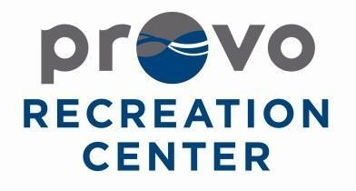Recreation Center Conduct
The Provo Recreation Center is a public facility intended for the use of residents of Provo City, Provo City Staff, as well as residents of surrounding cities. The Recreation Center is intended to be a welcoming and safe place for individuals to congregate and socialize. Participants of the Provo Recreation Center are expected to conduct themselves in a manner that most people would find reasonable and that does not infringe on the enjoyment of other participants. While an exhaustive list of inappropriate activities is impractical, the following outlines the basic principles of appropriate Recreation Center use.

Participants agree to observe the following when attending the Provo Recreation Center:

- Smoking is not permitted in the Recreation Center at any time.
- Alcohol is not permitted in the Recreation Center at any time.
- Offensive language is not permitted in the Recreation Center.
- The Recreation Center structure, grounds, furnishings and fixtures must be treated with care and respect at all times.
- Obtain entry through proper membership, daily admission fees, or City programs and events. Unauthorized entry will result in loss of facility privileges.
- No commercial activity, including requesting donations, private instruction, collect admission, sell product, or solicit individuals for agencies, personal services, or businesses.
- State and local policies, laws and regulations must be observed at all times.

Participants are expected to:

- Be able to function on their own or with the assistance of an escort, but independently from Provo City Staff or Recreation Center volunteers.
- Maintain personal hygiene that is healthy and inoffensive.
- Use voice, language and behavior that will not offend or disturb other participants or staff.
- Treat others with courtesy and consideration.
- Use computers for personal projects and education. All usage must be appropriate, inoffensive, and may not interfere with the operation of the City's computer system. Participants are NOT to download or install any programs onto the city's computers.
- Get permission for any photography or videography, personal, commercial, or otherwise, from staff prior to their filming.
- Observe all state and local laws, policies, ordinances, and regulations.
- Comply with any direction from Provo Recreation Center staff, and follow any other rules that they deem necessary and appropriate to provide patrons a safe and welcoming environment.
- Comply with Recreation Center employees in accordance with the rules and regulations outlined above as well as any other direction staff deem necessary to maintain the safety and enjoyment of all patrons. Failure to comply with staff requests, directions, or instructions will result in loss of privileges, including removal from the building and criminal trespassing.

Questions regarding the patron code of conduct can be directed to the Recreation Center Operations Supervisor or Recreation Division Director.

Safety Inspections and Investigations

The Provo Recreation Center will be utilizing a safety checklist to insure our commitment to safe workplace practices. This method will make certain that employers, supervisors, and all safety coordinators are involved in this process of avoiding and minimizing all work place hazards before they occur. In addition to the safety checklist inspection we will use the technique of risk mapping. Risk mapping safety inspections uses a drawing of the workplace using different colors and symbols to identify types of work place hazards. Each area marked as a hazard will be checked on a weekly basis, first by the employees working in that area and reported to the supervisor. The supervisor will then double check and confirm that the area meets the safety standards.

FITNESS CENTER SAFETY AND MAINTENANCE CHECKLIST

INSPECTOR: DATE:

FACILITY | S | U | STAIRCLIMBERS/STEPPERS | S | U
1. Rules and Regulations/Hours of Operations signage posted and visible to patrons |  |  | 1. Tread on steps in good condition
2. Emergency Exits signs illuminated |  |  | 2. Hardware secure
3. Fire Extinguishers inspections current
4. AED ( Automatic External Defibrillator) equipment inspection current |  |  | FREE WEIGHTS
5. Emergency evacuation plan posted |  |  | 1. Bolts, screws, adjustment mechanisms in good condition
6. Floor is non-slippery |  |  | 2. Weight plates have no cracks
EQUIPMENT – GENERAL
1. Is there adequate space between equipment (at least 36”) |  |  | ROWERS
2. Equipment checks performed daily |  |  | 1. Seat pad in good condition
3. Broken equipment taken out of service and signs posted |  |  | 2. Pulley cables in good condition
4. Cables, wires, chains secured
5. Machines have warnings/instruction labels
6. Bar and weight Storage Racks placed against wall
7. Free weights kept off floor when not in use
8. Equipment wiped clean daily (use mixture of mild antibacterial soap and water
9. Electrical equipment has surge protectors
TREADMILLS
1. Check operation of stop button weekly
2. Monthly check of belt tension and deck
3. Regularly vacuum underneath if on carpet
ELLIPTICAL/CROSS TRAINERS
1. Clean around alternator every 2-3 months
2. Intermediate shaft belt is tight
3. Hardware check every 2-3 months
EXERCIZE BIKES
1. Seat attached securely
2. Handlebars secured
3. Pedals secured |  |  | OTHER HAZARDS NOTED
OTHER CONCERNS: (List below, or in a separate sheet of paper and attach it to this list.)

Note: Mark S for satisfactory and U for unsatisfactory. If there are any unsatisfactory marks, please be sure to explain why.

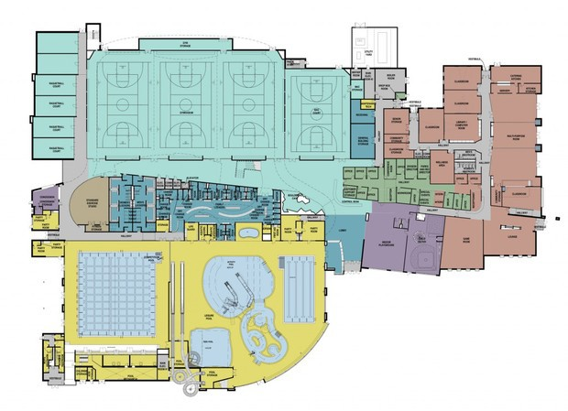

Key Risk Mapping
Emergency Exits Outlets Loose mats
Fans

Accident Reporting Analysis

In the event of an accident occurring with any person or persons within the fitness center, the accident shall be reported immediately. An accident report will be filled out thoroughly by an employee of the fitness center and filed no later than the end of the following business day.

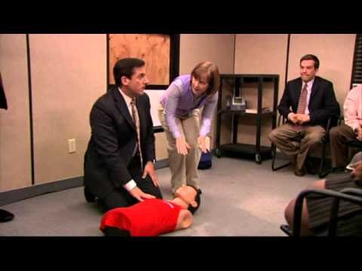

Accidents, Incidents, & First Aid

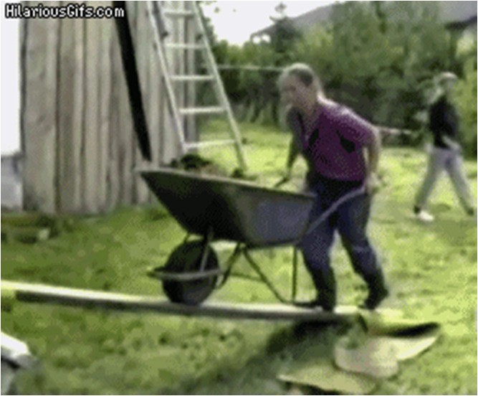

Accident VS Incident

- Accident: An unfortunate event, usually resulting in an injury, accidentally happening to an innocent patron.

Accident VS Incident

- Incident: An altercation between two or more patrons. This may or may not include violence.

Accidents & Incidents

- Both require filling out the appropriate paper work located in the Emergency Response binder. (digital copy – accident form)
- Both require the assistance of the shift lead.
- Both require all staff to be alert and helpful from the time of the event until the completion of all required actions.

Accident or Incident?

- An older patron is walking through the community side doors when they trip on the floor mat and fall. The patron complains of severe hip pain following the fall.
- During a pick up basketball game a scuffle occurs and results in one player punching another in the face.
- A woman comes to the front desk irate because she believes a man has been looking inappropriately at her teenage daughter.
- A fitness band snaps while in use causing the user to fling their arm abruptly resulting in a possible muscle tear.
- A patron approaches the desk reporting that their backpack has been stolen from their locker.
- You witness a patron cursing and yelling obscenities at a co-worker and the patron then throws a stack of papers from the desk in the employees face in frustration. You know the patron has a membership.

First Aid Equipment

Contained within the first aid bags:
- Band-Aids: fingertip, knuckle, butterfly, normal
- Antiseptic Wipes- Don’t use on open wounds; for open wounds use Neosporin
- Biohazard
- Gauze
- Gloves
- Icepacks
(Extra materials are stored at the front desk, in the back room, on the top shelf directly above the big safe.)

NEW EMERGENCY RESPONSE EQUIPMENT
located at the front desk, in the back room, on the shelf directly above the key box
- Glucose Gel- for diabetics
- Blood Stopper- gauze laced with coagulating agents- for excessive blood loss
- Aspirin- for emergency heart treatment

Act!

- “Remember, the difference between your doing something and doing nothing could be someone's life.” –Mayo Clinic

- Act immediately!
0 Don’t wait for someone to tell you what to do.
- Never hesitate to call 911!
0 Medical situations to call 911 include but are not limited to: chest pain, choking, difficulty speaking, drowning, numbness, poisoning, sudden intense pain, severe burns, a suicide threat and other serious medical problems. (American College of Emergency Physicians)

CPR Reminder

- CPR is used whenever the heart has stopped. This could result from drowning, a heart attack or electric shock.
- 100 beats per minute- “Staying Alive”
- Elbows locked, use the heel of your hand
- 30 pumps, then 2 breaths: repeat

Follow Up

  - Show shift lead where the accident and incident reports are located.
  - What is the difference between an accident and an incident?
  - Show shift lead where our first aid equipment is located; bags and emergency response equipment.
  - Show shift lead where the extra first aid materials are stored.
  - Explain when to call 911.
  - How and when do you perform CPR?

DATE AND TIME OF INCIDENT: Click here to enter a date.

PERSONAL DATA OF INJURED PARTY:

Name: Click here to enter name.

Age: Click here to enter age.

Phone Number: Click here to enter number.

ACCIDENT INFORMATION:

Description of the accident: Click here to enter description.

Rules disregarded (If Yes, must explain): Select Yes or No.

WITNESS DESCRIPTION:

Witness name: Click here to enter name.

Witness phone number: Click here to enter number.

Description of the accident: Click here to enter description.

CARE PROVIDED:

Did the facility offer to provide care? Select Yes or No.

Did the injured party refuse care? Select Yes or No. Description of care provided: Click here to enter description. Was EMS or Police Called? Select Yes or No.
Was the injured party transported to an emergency facility? Select Yes or No.

Did the injured party return to normal activity? Select Yes or No.

Were guardians contacted if the injured party is a minor? Select Yes, No or N/A.

FACILITY INFORMATION:

With as much detail as possible where did the accident occur in the facility? Click here to enter text.
Number of staff in the area: Choose a number.

Number of patrons in the area: Choose a number.

Names of staff members involved: Click here to enter text.

REPORT PREPARED BY:

Name: Click here to enter text. Position: Click here to enter text.

Date and time prepared: Click here to enter a date.

REPORT SEEN BY:

Name: Click here to enter text. Position: Click here to enter text.

Date:Click here to enter a date.

Name: Click here to enter text. Position: Click here to enter text.

Date:Click here to enter a date.

Name: Click here to enter text. Position: Click here to enter text.

Date:Click here to enter a date.

Emergency Procedure and Analysis

In case of an emergency, call 911 or contact one of the following according to the incident:

Title | Phone Number
Paramedics | (801) 852-6308
Fire Department | (801) 852-6321
Police Dispatch | (801) 852-6210
Non-Emergency Number | 311 or (801) 852-6000
Utah Valley Regional Medical Center | (801) 357-7850

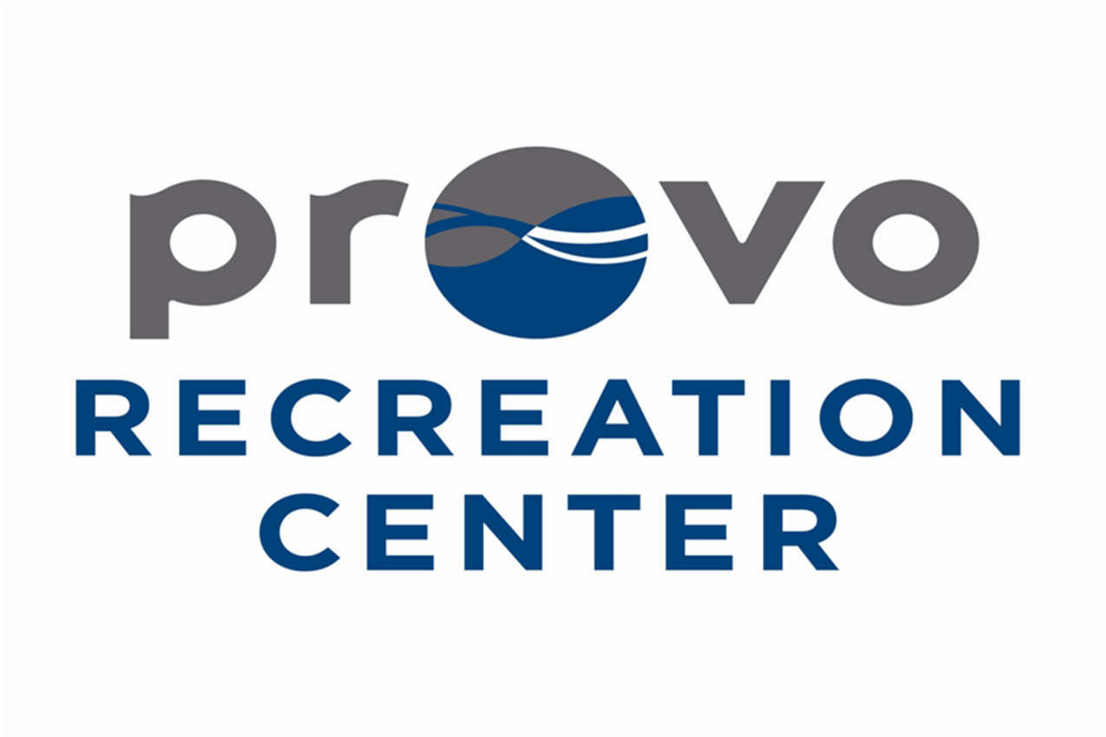

EMERGENCY ACTION
PLAN

Mission Statement

The mission of the Provo Parks and Recreation Department is to enhance quality of life by inspiring residents through our commitment to create dynamic parks, recreation facilities, programs and services of the highest standard.

Introduction

Emergencies, disasters, accidents and injuries can occur at any time usually without warning. Being prepared physically and mentally to handle emergencies is an individual as well as an organizational responsibility.

Provo City has established emergency procedures for you to follow so that the effects of these emergencies can be minimized. Your safety is of primary importance.

The purpose of these procedures is to acquaint you with an effective plan for handling possible emergencies and disasters. Once you are familiar with this information, you will be able to better protect yourself and others. You are encouraged to read this guide in its entirety to gain the knowledge to be able to act quickly in an emergency situation to minimize your exposure to danger. If you have questions or need further information, please contact your immediate supervisor.

The last page of this action plan is an Emergency Action Plan form that must be filled out and turned in to the Supervisor of your area. This information is very important and is site specific to your working environment. Use this form as a tool to be better prepared in the event of an emergency in your area

Emergency Directory

- In an emergency call 911 or 2222.
0 2222 is a number set up only for Provo City facilities. By dialing 2222, dispatch will automatically know the address you are calling from.

- Non-Emergency
0 Police…………………………………...801 852 6210
0 Fire/Paramedics……………….…..801 852 6321

Recreation Directory

Parks and Recreation Management
Director of Parks and Recreation – Roger Thomas | Office | 801 852 6601
 | Cell | 801 361 7959
Recreation Division Director – Scott Henderson | Office | 801 852 6602
 | Cell | 801 369 0267

Supervisors
Operations Supervisor – Bryce Merrill | Office | 801 852 6613
 | Cell | 469 951 0991
Aquatics Supervisor – Cathy Smits | Office | 801 852 7601
 | Cell | 801 319 1907
Recreation Supervisor – Brian Smith | Office | 801 852 6624
 | Cell | 801 602 7053
Sports Supervisor – Penn Almoney | Office | 801 852 6628
 | Cell | 801 310 3119

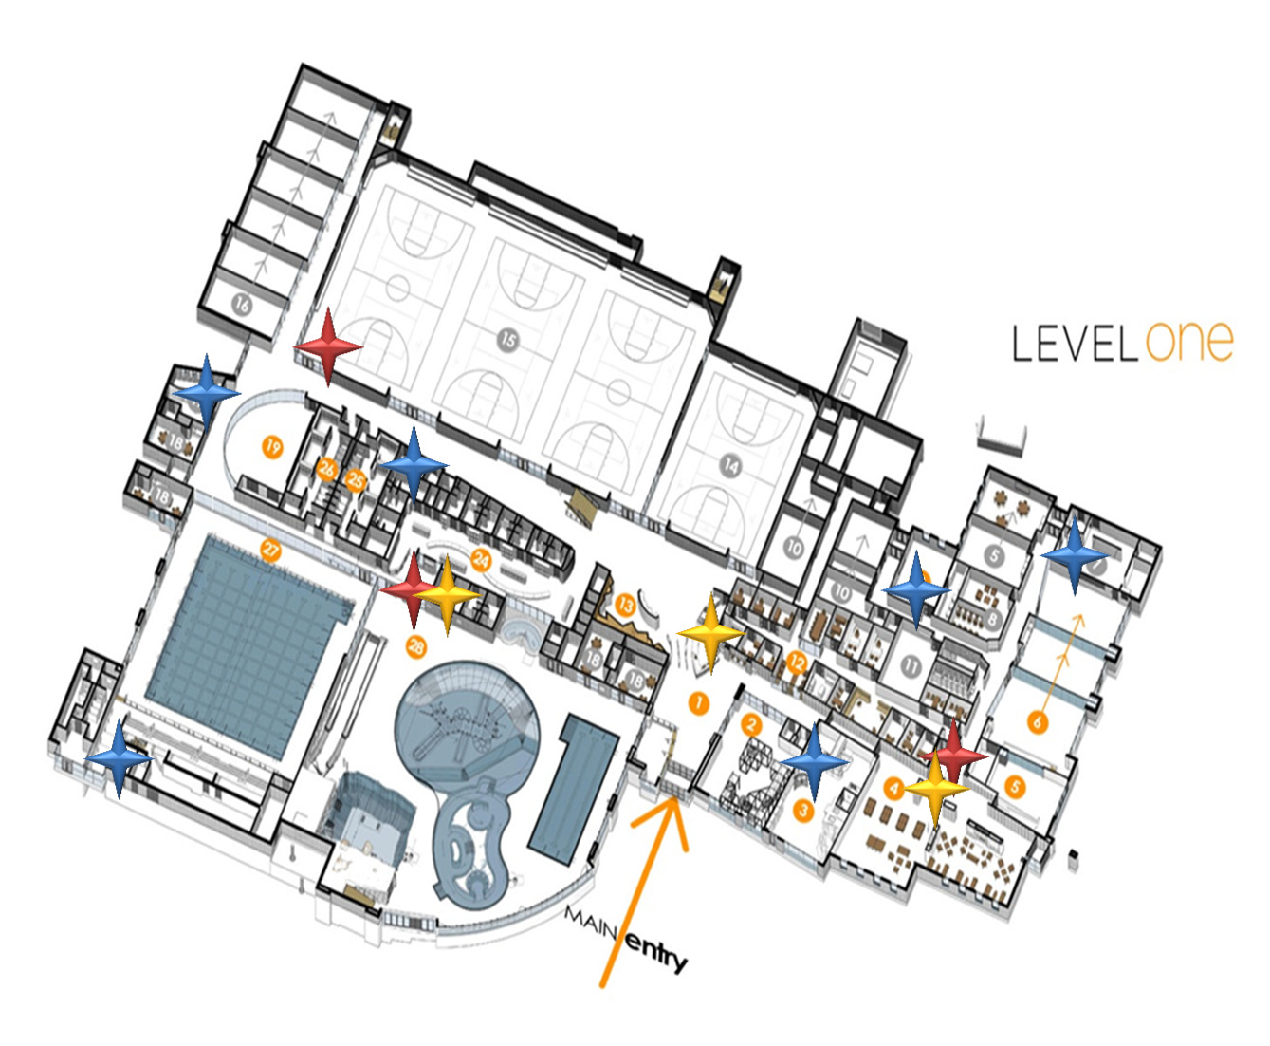

AED/Fire Extinguisher/First Aid Kit Locations

AED

Fire Extinguisher First Aid Kit

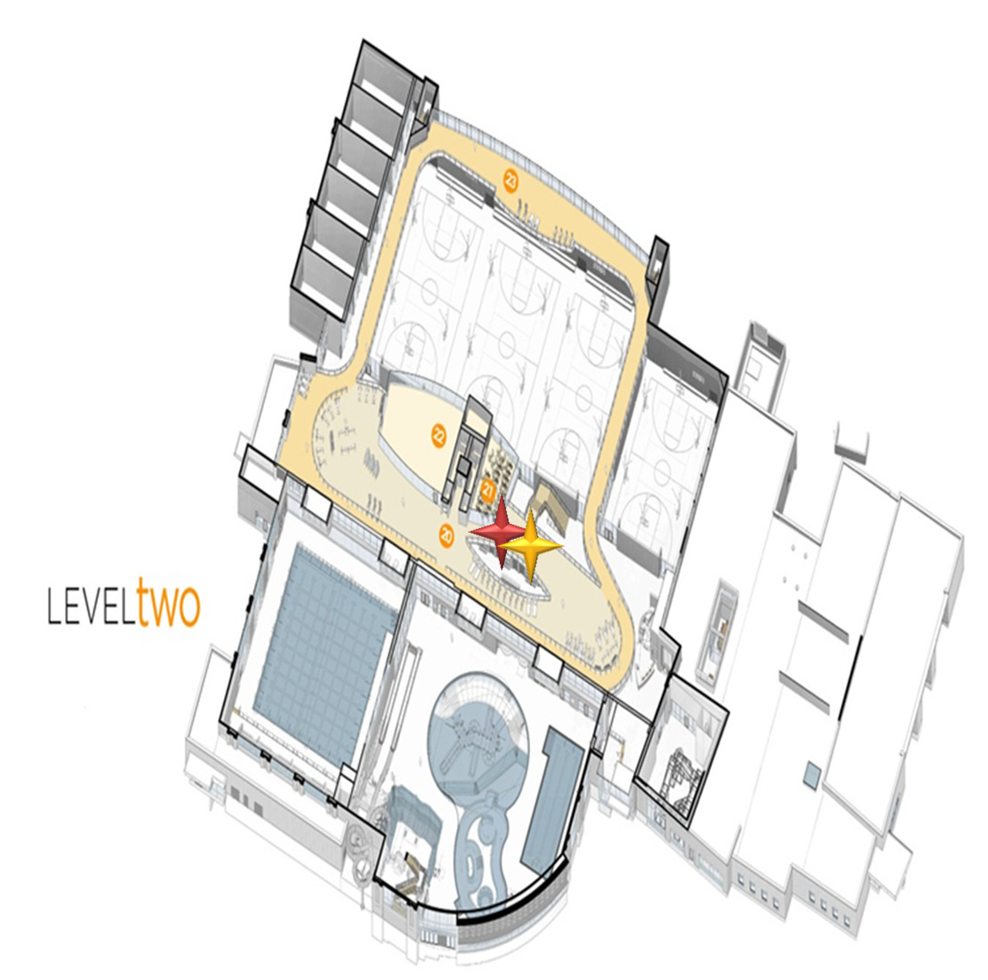

AED/Fire Extinguisher/First Aid Kit Locations

AED

First Aid Kit

Emergency Alarm System

- In the event of an emergency it may be necessary to evacuate the building. In order to activate the emergency evacuation alarm system pull the nearest fire alarm or from any desk phone activate the emergency evacuation alarm.

- In the event of a medical emergency it is important to get the Emergency Response Team to the scene as quickly as possible. In order to activate the Emergency Action Plan from the front desk activate the intercom system. Once the intercom is activated ask for employee assistance at your location.

- Example:
“Attention, employee assistance needed in the gym/front desk/child watch immediately. Repeat employee assistance needed in the gym/front desk/child watch immediately.”

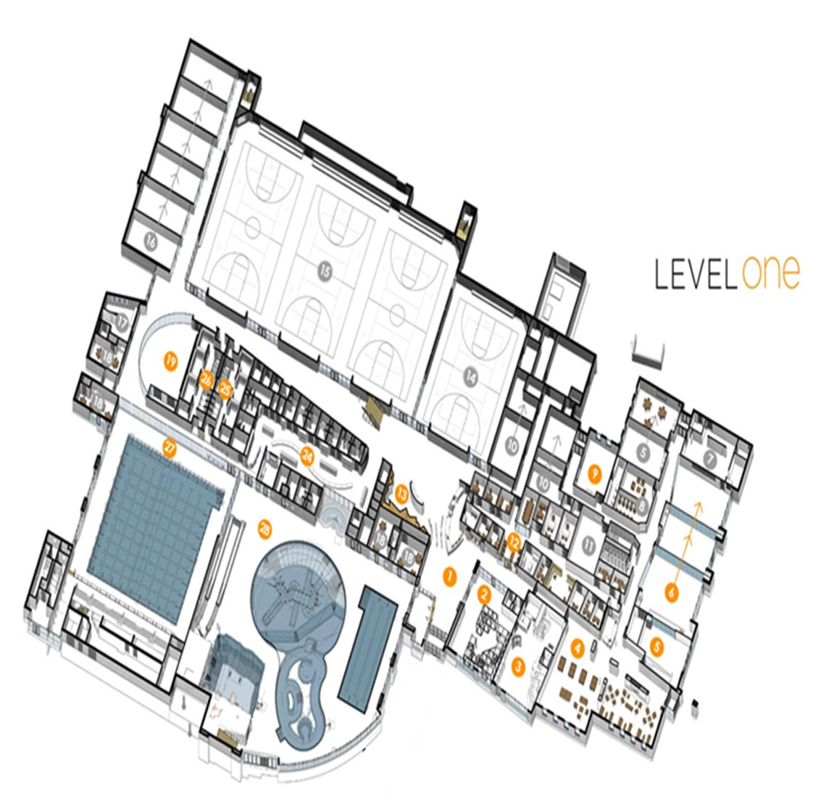

Emergency Evacuation Routes

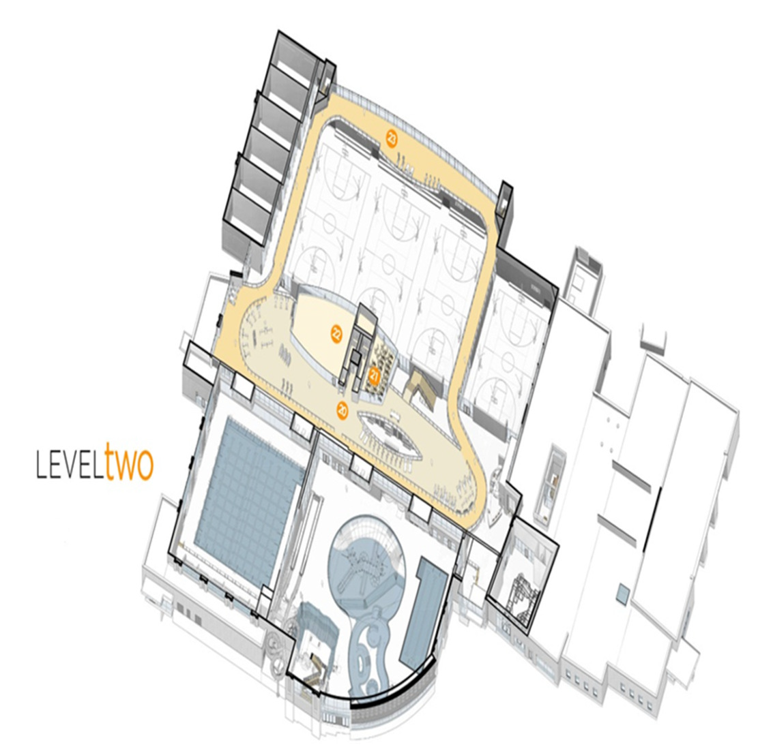

Emergency Evacuation Routes

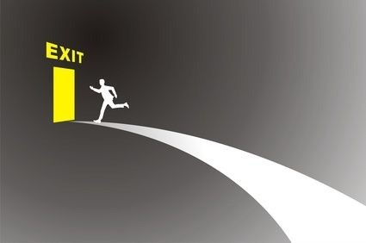

EMERGENCY RESPONSE

General Evacuation Procedures

- Evacuation of the building is REQUIRED when the building’s alarm system sounds or when instructed to do so.

- Building Evacuation:
0 Determine in advance the nearest exit to your work area and the route you will follow. Establish an alternate route in the event your first route is blocked or unsafe to use.
0 Help those that need assistance.
0 Supervisors and Coordinators should ensure that their area is clear before evacuating.
0 In case of fire, do not use the elevator.
0 Once outside, proceed to a designated meeting area at least 100 ft. from the building.
0 Meeting areas are flexible and might have to be adjusted depending on wind direction or the magnitude of the hazard.
0 Remain at the meeting place.
0 Attempt to account for all employees and other persons.
0 Stay at the designated evacuation area until the fire department or designated representative has given the “all clear” to re-enter the building.

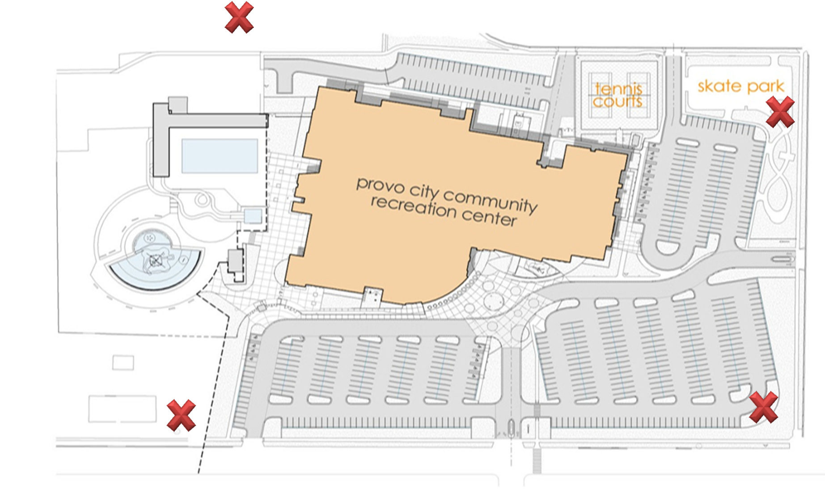

Designated Evacuation Areas

Fire Emergency

- If there is a fire, explosion or smoke in a building, take the following steps:
0 Remove anyone from immediate danger.
0 Pull the nearest alarm station and announce over the intercom to evacuate the building immediately and call 2222 or 911.
0 Proceed to the nearest exit in an orderly fashion. Assist members of the public and aide the handicapped out of the building. Do not use elevators.
0 Close all doors (do not lock the doors).
0 If smoke is present, stay close to the floor.
0 Once outside, proceed to a designated meeting area.
0 Attempt to account for all employees and other persons.
0 Stay at the designated evacuation area until the fire department or designated representative has given the “all clear” to re-enter the building.

Fire Emergency

- If you are trapped in a room:
0 Attempt to block the base of the door by stuffing a towel or blanket underneath the door.
0 Call 2222 or 911 and tell them your exact location.
0 If possible, open a window and attempt to climb out and remove yourself from the building.

- In the event of a fire, Provo City does not require employees to use a fire extinguisher. However, if you have received fire extinguisher training and are comfortable in extinguishing an early stage fire, you may attempt to extinguish the fire with a fire extinguisher if ALL of the follow conditions are met:
0 The fire alarm has been activated and all occupants have been evacuated.
0 If the fire is small (waste basket size) and has not spread from its originating point.
0 You have the correct type of extinguisher.
0 Your exit is clear and you can extinguish the fire with your back to the exit door.

Earthquake

- If you see or feel signs of an earthquake such as the ground shaking, hanging objects swaying or objects vibrating on shelves take the following steps:

- If Indoors:
0 Move away from bookshelves, cabinets or anything that might fall over.
0 Find a position under a table, desk or door frame.
0 Drop to crouched position, head down, hands clasped behind head.
0 Wait until tremors cease.

- If Outdoors:
0 Move away from the building. Avoid trees, poles and any overhead wires.
0 Wait until the tremors cease.

- After the earthquake stops:
0 Check for personal injuries.
0 Help those that need assistance.
0 Evacuate the building if necessary (using the predetermined routes).
0 Notify the Provo City Fire Department of any injuries or immediate health hazards.
0 Do not leave the premises until you are sure that the surrounding areas are safe (e.g. streets, highways, bridges).
0 If there is damage to the building, make sure the building has been checked by the fire department, building inspector and/or a designated representative and deemed safe before re-entering the building after an earthquake.

Bomb Threat

- Bomb threats may be received by phone, mail, person-to-person, e-mail, etc. In most cases, however, the threat will be made by phone.

- In the event of a bomb threat over the phone, take the following steps:
0 The person receiving the call should try to remain calm, note the time, ask questions and try to write down as much information as possible.
x Where is the bomb?
x What time will the bomb go off?
x What does it look like?
x What kind of explosive is it?
x Male/female
x Age (older/younger)
x Ethnic origin
x Speech characteristics
x Background noises
- During the call if possible, indicate discreetly to another employee to call 2222 or 911 to report a bomb threat and notify a supervisor. If not possible, immediately call 2222 or 911 after hanging up and begin evacuating the building.
- Activate the alarm system and announce over the intercom that there is an emergency situation and the building must be evacuated immediately.
- Help those that need assistance.
- Attempt to account for all employees and other persons once in designated area.
- Stay at the designated evacuation area until the fire department, police department or designated representative has given the “all clear” to re-enter the building.

Suspicious Device

- If you receive or find a suspicious device:
0 Do not touch or approach a suspicious device. Safely remove yourself from the area.
0 Notify a supervisor and remove any public or staff members from the area.
0 Avoid use of two-way radios and other wireless devices.
0 Notify the police department by calling 2222 or 911.
0 Follow the supervisor’s instructions for appropriate emergency evacuation.
0 Attempt to account for all staff and remain in designated area until contacted.

Hazardous Material Spill

- If there is a hazardous material spill in your area, you should take the following steps:
- For minor spills or contamination:
0 Evacuate all staff and public in the area.
0 Notify a supervisor.
0 If properly trained, clean up the spill according to the procedures in the MSDS manual.
0 During the cleanup procedure, be sure to wear the appropriate protective clothing, such as gloves, protective eyewear, apron, etc.
0 Dispose of the chemical material in an approved and safe manner.

- For major spills or contamination:
0 Evacuate all staff and public in the area immediately.
0 If possible, without exposing yourself to the chemical, eliminate all possible sources of ignition if the chemical is flammable or possibly flammable. If the chemical is volatile, seal off the area by closing any doors or windows. Activate the fire alarm and announce over the intercom to evacuate the building immediately.
0 Immediately call 2222 or 911. Give your name; the chemical and amount involved; the room number and building; and the names of any person who may have been contaminated or exposed.
0 If a person has been exposed by inhalation, immediately move the person to an area where fresh air is available and promptly seek medical help. If the person has been exposed by contact, remove any contaminated clothing and wash the affected area immediately with copious amounts of fresh clean water for at least 15 minutes and seek immediate medical attention.
0 Decontamination procedures should be carried out by experts who are equipped to safely cleanup and dispose of the chemical involved.
0 Attempt to account for all employees and other persons.
0 Stay at the designated evacuation area until the fire department or designated representative has given the “all clear” to re-enter the building.

Dangerous Person/Active Shooter

- If you see an armed or potentially dangerous person:

- Run
0 If there is an escape path, attempt to evacuate.
0 Evacuate whether others agree to or not.
0 Leave your belongings behind.
0 Help others escape if possible.
0 Prevent others from entering the area.
0 Call 2222 or 911 when you are safe.

- Hide – If evacuation is not possible, find a place to hide.
0 Hide out of the shooter’s view.
0 Provide protection if shots are fired in your direction.
0 Do not trap or restrict your options for movement.

- Fight – As a last resort and only if your life is in danger.
0 Attempt to incapacitate the shooter.
0 Act with physical aggression.
0 Improvise weapons.
0 Commit to your actions.

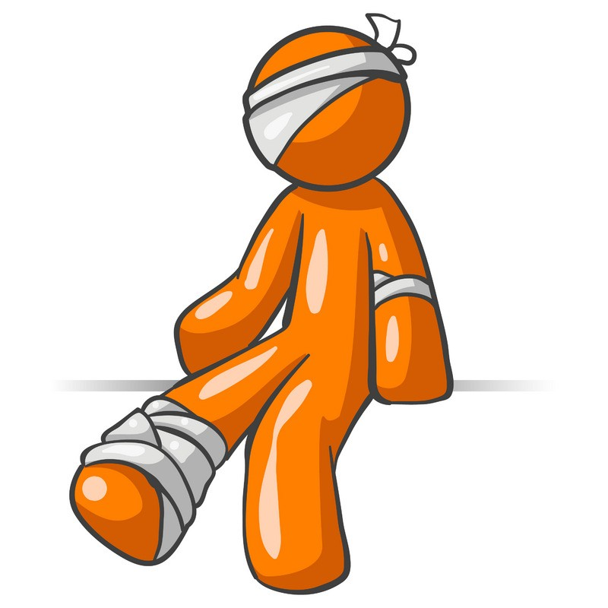

Injury Treatment

Life Threatening Injury

- If a serious injury or potentially life-threatening situation occurs:
- Make sure the situation is safe, put on personal protective equipment, approach the victim and determine whether or not they are conscious by tapping them on the shoulder and asking if they are ok.

- If the victim is CONSCIOUS:
- Obtain consent from the victim by stating your name and asking if you can help them.
- Perform a secondary assessment to determine what life-threatening conditions exist (severe bleeding, trouble breathing, chest pain, severely broken bones, etc.).
- If life-threatening conditions exist, immediately tell another staff member to go to the nearest phone and activate the emergency action plan over the intercom and call 2222 or 911.
- Tell another staff member to retrieve the AED.
- Keep the victim still and comfortable. Continue to monitor the victim’s level of consciousness until more trained personnel arrive.

- If the victim is UNCONSCIOUS:
- Immediately tell another staff member to go to the nearest phone and activate the emergency action plan over the intercom and call 2222 or 911.
- Tell another staff member to retrieve the AED.
- Perform a primary assessment to check for life-threatening conditions.
- Continue to provide care for conditions found until more trained personnel arrive.

0 If no other staff members are present to assist, instruct a responsible bystander to go to the front desk and notify them to call 2222 or 911 and to retrieve the AED.
0 If the victim is unconscious the AED should be used immediately when it becomes available.

First Aid Injury

- For minor injuries: (minor injuries include minor cuts, scratches, sprains, etc.)

- Personal protective equipment must be worn at all times.
- Stabilize the victim or injury. Do not move the victim unless the victim is in immediate danger.
- Send another staff member to retrieve the first aid kit from the nearest location and perform any first aid needed.
- Offer the victim ice or first aid materials as needed. These are the only medical items we will give out.
- Do not attempt to diagnose any medical conditions.
- Fill out an accident report form and submit to your supervisor.
- Employees will not give out information regarding any accident report except to the police or paramedics. Refer all questions to your supervisor.

- First Aid Kit locations:
0 Lifeguard room
0 Front desk
0 Senior Side desk
0 Upper level desk

- Refusal of care:
0 If at any time an adult refuses first aid, paramedic or other medical assistance when you believe it necessary, completely fill out an accident report stating the nature of the situation and that assistance was refused. Please be sure to have the person sign the form.

- If at any point you feel you may need more assistance, stabilize the victim and send another staff member to get someone from the lifeguard staff.

Employee Injury

- If an employee is injured on the job:
- Employee
- Report any injury or accident to your supervisor and get treatment at the approved facility if needed.
- If treatment is needed, tell doctor your workers comp carrier is Traveler’s Insurance and that the City offers modified duty.
- Keep your supervisor and HR updated on any work restrictions, time needed for treatments, doctor’s notes, workers comp issues or medical status changes.
- Supervisor
- Ensure the employee gets treatment at the appropriate facility and submits to drug and alcohol testing required by policy*.
- Within Provo City limits, call 311 to log the accident. Call 801 852 6000 to log the accident if outside Provo City limits.
- Submit accident report electronically on the intranet at http://sire/sire within 24 business hours. For questions call 801 852 6198.
- Provide or request from HR, modified duty for anyone who has work restrictions. Keep the supervisor above you informed of the employee’s medical status.

WORKMED |  | INSTACARE |  | UVRMC-HOSPITAL
NON-EMERGENCIES |  | USE ONLY IF WORKMED IS CLOSED |  | EMERGENCIES ONLY
Springville | Orem | Provo | Orem | Provo
385 S 400 E | 830 N 980 W | 1134 N 500 W | 1975 N State | 1034 N 500 W
801 491 6400 | 801 724 4000 | 801 357 1770 | 801 714 5000 | 801 357 7001
8 am - 5 pm | 8 am - 5 pm | 9 am - 9 pm | 8 am - 10 pm | 24 hours a day
Open Monday – Friday |  | Open 7 days a week |  | Open 7 days a week

Other Incidents

Fighting/Violence

- If violence or threat of physical harm to staff or other persons occurs:
- Immediately remove yourself from the dangerous situation.
- Verbally attempt to stop the altercation. Never under any circumstance should you physically become involved in the situation.
- Notify a supervisor.
- Observe and document the incident with as much detail as possible.
- If at any point you feel the situation will not resolve itself quickly and is becoming dangerous to you or someone else call 2222 or 911.
- After the altercation has ended, those involved should be escorted out of the building.

Utility Failure

- Examples of utility failure that may occur are electrical outage, plumbing failure/flooding, natural gas leak, ventilation problems and/or elevator failure.

- In the event of a failure, immediately notify Facilities Maintenance at extension 6630 or 6633. For emergencies or after hours call 2222 or 911.

- If there is potential danger to you or other occupants:
0 Evacuate all staff and public in the area.
0 Notify a supervisor and call 2222 or 911.
0 In a situation where a building needs to be evacuated, proceed to the building specific evacuation area.
0 Help those that need assistance.
0 Do not use elevators.
0 Attempt to account for all employees and other persons.
0 Stay at the designated evacuation area until the fire department or designated representative has given the “all clear” to re-enter the building.

Emergency

Response Binder

Evacuation
Locations

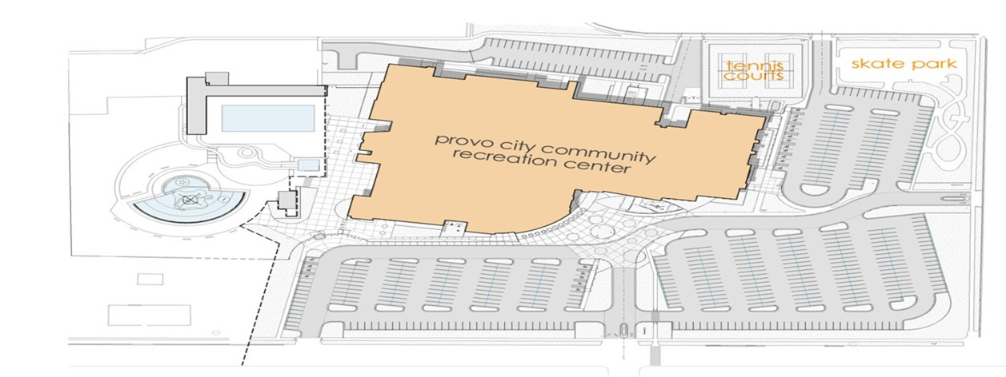

General Evacuation
Procedures
- Building Evacuation:
  - Evacuation of the building is REQUIRED when the building’s alarm system sounds or when instructed to do so.
  - Determine in advance the nearest exit to your work area and the route you will follow. Establish an alternate route in the event your first route is blocked or unsafe to use.
  - Help those that need assistance.
  - Supervisors and Coordinators should ensure that their area is clear before evacuating.
  - In case of fire, do not use the elevator.
  - Once outside, proceed to a designated meeting area at least 100 ft. from the building.
  - Meeting areas are flexible and might have to be adjusted depending on wind direction or the magnitude of the hazard.
  - Remain at the meeting place.
  - Attempt to account for all employees and other persons.
  - Stay at the designated evacuation area until the fire department or designated representative has given the “all clear” to re-enter the building.

Staff
Responsibilities

Staff 1: Shift Lead
- Grab Emergency Binder; distribute cards to employees

- Make announcement to patrons and staff

- Contact Full Time Staff: Recreation Director, Operations Supervisor etc. to establish chain of command
- Ensure Guest Service staff have enacted their emergency response systems
- Prioritize Child Watch and other areas where children are supervised
- Make contact with first responders; provide them information
- After facility has been evacuated, make assignments for guest service staff to assist with entry back into facility
- Take roll of all staff

- Fill out post-incident paperwork and submit within 24 hour time period

Staff 2: Community Area
- If Community staff on—assign to them;
- Take Register key and ensure all equipment locked up/stowed
- Begin sweep of community side: art hallway, classrooms, kitchen, MPR, game room/lobby
- Wait outside community entrance to ensure patrons do not re-enter facility until instructed
- Assist with evacuation areas, as specified by Lead Staff or FT staff

Staff 3: Child Watch
- Grab Parent Sign-in log and facility key
- Use Safety rope and assign 1-2 staff to take all walking children with safety rope through gate in playground towards designated facility meeting spot
- Have other staff carry infants and non-walking children towards safety area
- Use any additional staff to help corral children while in designated waiting area.
- Instruct parents that check-out will not be possible until we can return to facility and ensure proper check-out policies for children
- Take roll of all children once outside
7. Assist with evacuation areas, as specified by Lead Staff or FT staff

Staff 4: Front Desk Area
- Staff 4: Order and organize evacuation of indoor playground through to main entrance; perform sweep of play structure if necessary
- Staff 5: Stand by main entrance to ensure successful exit and no reentrance for patrons; clear bath from aquatics emergency exits if necessary
- Staff 6: Hit emergency switch for gate to assist with mass exodus of patrons in emergency; stay with intercom (if safe) to ensure timely communication with patrons
- Staff 7: Sweep of gymnasium areas and racquetball hallways; supervise exit out the emergency exits along back of facility and direct staff towards safe locations
- Staff 8: Sweep of family locker lounge and locker rooms (with aquatics staff) Assist with evacuation areas, as specified by Lead Staff or FT staff. Coordinate with Lead staff of aquatics to ensure safe evacuation of all aquatics patrons

Staff 5: Front Desk Area
- Staff 4: Order and organize evacuation of indoor playground through to main entrance; perform sweep of play structure if necessary
- Staff 5: Stand by main entrance to ensure successful exit and no reentrance for patrons; clear bath from aquatics emergency exits if necessary
- Staff 6: Hit emergency switch for gate to assist with mass exodus of patrons in emergency; stay with intercom (if safe) to ensure timely communication with patrons
- Staff 7: Sweep of gymnasium areas and racquetball hallways; supervise exit out the emergency exits along back of facility and direct staff towards safe locations
- Staff 8: Sweep of family locker lounge and locker rooms (with aquatics staff) Assist with evacuation areas, as specified by Lead Staff or FT staff. Coordinate with Lead staff of aquatics to ensure safe evacuation of all aquatics patrons

Staff 6: Front Desk Area
- Staff 4: Order and organize evacuation of indoor playground through to main entrance; perform sweep of play structure if necessary
- Staff 5: Stand by main entrance to ensure successful exit and no reentrance for patrons; clear bath from aquatics emergency exits if necessary
- Staff 6: Hit emergency switch for gate to assist with mass exodus of patrons in emergency; stay with intercom (if safe) to ensure timely communication with patrons
- Staff 7: Sweep of gymnasium areas and racquetball hallways; supervise exit out the emergency exits along back of facility and direct staff towards safe locations
- Staff 8: Sweep of family locker lounge and locker rooms (with aquatics staff) Assist with evacuation areas, as specified by Lead Staff or FT staff. Coordinate with Lead staff of aquatics to ensure safe evacuation of all aquatics patrons

Staff 7: Front Desk Area
- Staff 4: Order and organize evacuation of indoor playground through to main entrance; perform sweep of play structure if necessary
- Staff 5: Stand by main entrance to ensure successful exit and no reentrance for patrons; clear bath from aquatics emergency exits if necessary
- Staff 6: Hit emergency switch for gate to assist with mass exodus of patrons in emergency; stay with intercom (if safe) to ensure timely communication with patrons
- Staff 7: Sweep of gymnasium areas and racquetball hallways; supervise exit out the emergency exits along back of facility and direct staff towards safe locations
- Staff 8: Sweep of family locker lounge and locker rooms (with aquatics staff) Assist with evacuation areas, as specified by Lead Staff or FT staff. Coordinate with Lead staff of aquatics to ensure safe evacuation of all aquatics patrons

Staff 8: Front Desk Area
- Staff 4: Order and organize evacuation of indoor playground through to main entrance; perform sweep of play structure if necessary
- Staff 5: Stand by main entrance to ensure successful exit and no reentrance for patrons; clear bath from aquatics emergency exits if necessary
- Staff 6: Hit emergency switch for gate to assist with mass exodus of patrons in emergency; stay with intercom (if safe) to ensure timely communication with patrons
- Staff 7: Sweep of gymnasium areas and racquetball hallways; supervise exit out the emergency exits along back of facility and direct staff towards safe locations
- Staff 8: Sweep of family locker lounge and locker rooms (with aquatics staff) Assist with evacuation areas, as specified by Lead Staff or FT staff. Coordinate with Lead staff of aquatics to ensure safe evacuation of all aquatics patrons

Staff 9: Fitness
- Coordinate with three instructors in studios (if applicable) to dismiss patrons and help with safe exit
- Walk fitness mezzanine to evacuation
- Instruct patrons to use stairs, and assist any patrons with mobility disabilities to safely exit down stairs
- Direct patrons towards emergency exits along track (as available)
- Check in with lead staff once down stairs to be assigned to an evacuation area

Staff 10: Concessions
- Take register key. Close down concession gate
- Turn off all ovens, equipment, etc.
- Sweep Vets Pool plaza and guide patrons out towards kiosk
- Coordinate with Shift lead for supervision of evacuation point

Staff 11: Kiosk
- Take register key. Lock Kiosk building. Take a walkie talkie with you
- Coordinate with outdoor vets pool supervisor to ensure safe exit of all vets pool patrons
- Sweep Vets Pool, comp pool bathrooms, and other outdoor areas
- Wait outside vets pool kiosk gates to ensure no re-entrance until facility has been cleared

Releases, Waivers, and Agreements to
Participate

Liability Release Form

In consideration of my use of the exercise equipment and facilities provided by the Provo Recreation Center, I expressly agree and contract, on
behalf of myself, my heirs, executors, administrators, successors and assigns, that the Provo Recreation Center and its insurers, employees, officers, directors, and associates, shall not be liable for any damages arising from personal injuries (including death) sustained by me, or my guest in, on, or about the premises, or as a result of the use of the equipment or facilities, regardless of whether such injuries result, in whole or in part, from the negligence of the Provo Recreation Center. By the execution of this agreement, I accept and assume full responsibility for any and all injuries, damages (both economic and non-economic), and losses of any type, which may occur to me or my guest, and I hereby fully and forever release and discharge the Provo Recreation Center, its insurers, employees, officers, directors, and associates, from any and all claims, demands, damages, rights of action, or causes of action, present or future, whether the same be known or unknown, anticipated, or unanticipated, resulting from or arising out the use of said equipment and facilities.
I expressly agree to indemnify and hold the Provo Recreation Center harmless against any and all claims, demands, damages, rights of action, or causes of action, of any person or entity, that may arise from injuries or damages sustained by me or my guest.
I agree to be solely responsible for safety and well being of my guest and myself. I understand that the Provo Recreation Center does not provide supervision, instruction, or assistance for the use of the facilities and equipment.
I agree to comply with all rules imposed by the Provo Recreation Center regarding the use of the facilities and equipment. I agree to conduct myself in a controlled and reasonable manner at all times, and to refrain from using any equipment in a manner inconsistent with its intended design and purpose.
I understand and acknowledge that the use of exercise equipment involves risk of serious injury, including permanent disability and death.
I understand and agree that the Provo Recreation Center is not responsible for property that is lost, stolen, or damaged while in, on, or about the premises.
I understand and agree that my use of the facilities and equipment is only to be undertaken on my own personal time, and that my use of the facilities and equipment is not within the course or scope of my employment.

I HAVE READ THE FOREGOING WAIVER AND RELEASE OF LIABILITY AND VOLUNTARILY EXECUTED THIS DOCUMENT WITH FULL KNOWLEDGE OF ITS CONTENT.

Date:

Signature:

Print Name:

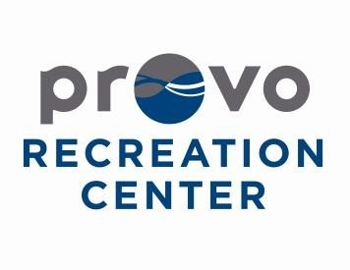

Memberships

TWO-WEEK TRAINING

Setting up a Membership

1. Check for proof of residency and dependency if applicable 2. Have patron fill out all necessary paperwork
3. Check RecPro to make sure they are not already in our system
4. If they are already in our system make sure all info and pictures are up to date
5. If not, add them as a new customer, enter all information and take pictures and then hit save at the top.
6. Select membership button on left hand side and select new membership
7. Once in the membership screen select the correct type of membership, length and patrons included.
8. On annual passes with recurring billing make sure to select the correct date (see additional slide for more detail)
9. Add membership to cart and complete checkout.
10. Double check to make sure patron has filled out entire front and back of the form 11. Fill out staff portion of the paperwork and file in the correct folder at front desk.

Who can be on the membership?

● Youth: 3-17 years old, they need approval/parental signature on membership application
● Adult: 18-59 years old
● Senior: 60+ years old, if getting a senior couple only one needs to be 60+ for both to get senior pricing (same with senior pass holders)
● Couple: two adults/seniors who are married/claim each other on taxes
○ If a single parent of a single child wishes to get a membership, they are
able to get the adult couple pricing instead of purchasing the family membership
● Family: two adults who are married/claim each other and their
dependents 21 and younger (up to 6 members total. Each family member in addition can be added on with ‘family extra’ in RecPro.)

Proof of Residency/Dependency

● Documents that work for residency
○ Official piece of mail dated within the last 30 days, preferably some sort of bill
○ Rental agreements/housing contract
○ 1st page of tax return
*as a last resort, you can accept a current driver’s license
● Documents that work for dependency
○ Tax documents that list dependants and spouses
○ Marriage certificate and birth certificates
○ Health insurance cards with all names listed

Recreation Paperwork

Each membership has corresponding paperwork:
● For corporate memberships, make sure you list the corporation at the top of the membership application and file in the correct folder at the front desk.
● For Silver Sneakers, the Senior Pass, the Child Watch Pass, and United Healthcare, the correct form can be found in the organizer at the front desk between computers 1 and 2, or in the organizer at the community desk.
● For memberships with recurring billing, be sure to have the patron fill out the payment authorization paperwork and staple to membership application.
● For all other memberships, use the normal membership application.

Corporate Memberships

● Check corporate membership binder/google docs tab to see how to proceed correctly.
● Either check binder under correct tab for the list of employees or have them show you their employee ID. Occasionally they will have a letter from their employer as proof.
● When selecting membership in RecPro make sure to select the correct corporation, proceed as normal.
● File membership paperwork in corresponding corporate membership folder with correct label at top.

Recurring Billing

● Patrons must fill out payment authorization
● Make sure they understand their payment date cannot be changed
● Explain the first month will be prorated, so their first payment will be from start date up to selected payment date plus first month’s payment.
● When setting up the recurring billing, type out
credit card information, never hit swipe card!

*All child watch passes must be set up for recurring billing

Recurring Billing

● Payments toward the membership MUST be made through the automatic payment process
○ We cannot accept any form of payment for monthly payments other than on the original sign-up day
● Update payment information
○ If a payment has not gone through, the only option is to update the Credit Card payment information
○ Find the person’s account, go to “On Account” >
“Memberships” > Highlight the correct membership and select “Change Recurring Payment Contract”
○ Always select Credit Card and type out the credit card info; never hit swipe card! Delete any other cards on file
• Multiple Family/Family Extra memberships and all Child Watch memberships
○ Change all the current memberships to the new card!

Membership Cancellation

For paid in full memberships:
We will keep a set amount for each month used and will refund the rest of the payment (see Cancellation Policy).

For recurring billing:
In order to stop billing before the annual contract has been fulfilled, they must pay the cancellation fee (see Cancellation Policy).

Exception Form

If their situation, familial or residential, doesn’t abide by the basic rules, have them fill out an exception form (found in organizers). Inform them that most exceptions are denied, but they are welcome to ask (use positive language, but be realistic with them).
They will be contacted within 2 business days. For further questions ask a shift lead.

Answer these with a shift lead

I have a family membership and want to add grandma so she can bring the kids, is that allowed?

Can my brother and I get an adult couple membership?

I’m a single mom of a ten year old do I have to get the family membership or can I get the adult couple membership?

We have a foreign exchange student coming to live with us, can I add him to our family membership?

My wife is 50 and I’m 62 can we get the senior couple membership?

My monthly payment didn’t go through for my family membership. Can I just pay $44 in cash right now?

Methods of Insuring Against Risk

The Provo Recreation Center is insured with an umbrella policy through Geico, covering injuries, damages to property, certain lawsuits, and personal liability situations listed within the policy.

In-Service Training

Two Week Training: Community Desk

Opening/Closing Community

• “General Recreation Center Information” binder
• Opening and closing duties, questions or other general questions
• Computer logins and passwords
• Check phone messages, user: extension # | password: provo
• Opening:
• Turn lights on, login to computers, open Rec Pro membership check-in and wellness room camera, unlock wellness and library. Unlock main doors at 8am. Wednesdays and Thursdays unlock art room & kiln door
• Closing:
• Clean up, lock all doors, logoff or restart all computers (never shutdown or lock), log out of phones, turn off lights and fireplace.

Library, Game Room, and Wellness

 Library Hours: 8am-3pm (Monday-Friday)
¡○ Lock the door at 3pm, unless computer class is in progress
¡○ Library book check-out on Google Docs (link saved on comp. #1)

 Wellness Room: 8am-10pm (Monday-Saturday)
¡○ Every patron needs to have a membership or pay the daily fee
¡○ A non-senior may work-out with a senior, but would still have to have a membership or pay and be over 14 years old.

 Game Room: Senior Hours 8am-1pm (Monday-Friday)
¡○ Must take photo ID for equipment
¡○ $2/person for those without memberships or day pass stamp
¡○ A guest may play with a senior if they have a membership/day pass stamp or pay community fee ($2)
¡○ No food or drinks (except water) allowed in game room or lounge

Senior Activities

 Senior Activities
¡○ Walking Track: Monday-Friday 10am- 12pm
¡○ Swim: Monday/Wednesday/Friday, 8am- 8:45am
¡○ Tai Chi: Monday/Thursday 10:30am
¡○ Zumba Gold: Monday/Wednesday/Friday 1:30pm
¡○ Bingo: Tuesdays 1pm
¡○ Book Club: 2nd Tuesday of each month 1pm
÷ Check out books at the meeting or fill out information on the slip inside the canvas bag hanging behind the door. They can have food for their meetings.
¡○ *Times for the above ongoing programs can be found on the first page of the Senior Monthly Newsletter.
¡○ Senior Tours/Adventure Club- See current list at desk

Tracking Senior Services

 The “SENIORS” binder has the tracking sheets for most of the senior services we provide:
¡○ Senior Lunches: Waiting list and kitchen half sheets
¡○ Senior Food Bags (“Brown Bags”)
¡○ Senior Legal Clinic
¡○ Wellness Coaching
¡○ Senior Bus/Van Ride Information

**Tax Counseling Appointments for seniors are running from February to March 2016 and sign-ups are in a small blue binder. The information you need to know for signing a patron up is in the binder.

Mountainland: Senior Lunch & Ensure

 Bre is the Senior Programs Specialist, Hours: Monday-Friday 10am-2pm, phone: 801.852.6043, email: bdraney@provo.org. If you have questions, contact Bre.

 After 2pm do not sign-up people for lunches, Ensure, brown bags. If patrons want to sign-up, then ask them to come in or call between 8am-2pm, Monday through Friday.

 Senior Lunch
¡○ The following is for the Monday-Friday 8am-2pm shift:
÷ Put Donation box out
÷ Log into Mountainland (see login information in SENIOR binder)
÷ Print lunch list under “Reports” in Mountainland (check by patron name when give ticket), prepare kitchen information half-sheet, and count tickets
÷ Information for patrons is in the yellow folder labeled “Senior Lunch Handout”

 Ensure (Click here for the Ensure Process)
¡○ Information sheet for patrons is in the yellow folder labeled “Senior Ensure Handout”
¡○ Hours for pick-up are Monday-Friday 8am-2pm, so only the morning staff will be responsible for this.
÷ Check if patron is in Mountainland system. If not, they need to be entered before their prescription can be processed by Mountainland.
÷ Select patron name, then click Client Ensure
¢ Verify that the patron has not picked up more than 2 cases for the month, then submit the flavors they receive.
÷ They can donate money in the donation box. Make checks payable to Provo City.

Senior Memberships

 Senior Pass: $10 for residents | $100 non-residents
¡○ They must show proof they live in Provo.
 Silver Sneakers – Benefit through their insurance
¡○ If they have the 16 digit number it can be checked on the
website: https://fitness.healthways.com | Username: zrecreation, Password: recreation
¡○ They can contact their insurance to see if eligible/sign-up
 Silver & Fit
¡○ Refer them to Kari or Kaiti for verification
¡○ Fill out regular Recreation Center membership form
 Recreation Center membership for senior/senior couples
¡○ If one spouse is over 60, they both can be on a senior couple membership.

Random

 Chuck-A-Rama Cards
¡○ $1 per card, enter in POS
¡○ Till bags have some and there are extras in the big safe. Notify Bre when low.
 Restroom
¡○ Refer them to the “public restrooms” down the entry hall. If they have a day pass or membership, they are allowed to use the “pay zone” restroom.
 Control Points
¡○ Every patron needs to check-in at the desk and scan their card each time they pass the desk.
¡○ It is the staff’s responsibility to know who is in the area.
 Cord box check out (bottom drawer of computer #1)
¡○ Check out the cords needed under equipment checkout-MUST TAKE collateral (Photo ID ONLY)-please specify what was checked out of the box and make sure all is returned
 Classroom and MPR rentals: please refer them to Kaiti @ ext. 7613
 Classes
¡○ Patrons pay for the class and don’t have to have a membership.
¡○ The porcelain class is allowed to bring food into the facility.

Questions

• How do you log into the membership scan computer?
• How do you log on/off phones and check messages?
• How do you log into Mountainland and where are the passwords?
• When does a patron need to pay the $2 fee?
• Explain the different senior memberships.
• Where do you find the “Visitor and Waiting List” and kitchen half sheet for senior lunches?
• What are the hours for Ensure and Brown Bag pick up?
• What is the next Senior Tour?
• How do you signup a senior for a Legal Clinic appointment or a Tax Counseling appointment?

Public Relations

In the event of an accident, public lawsuit, or any other public relations incident, the following people will be contacted to address the public and press with a statement on behalf of the Provo Recreation Center:

- Scott Henderson, Recreation Director
- Bryce Merrill, Recreation Center Manager

No other employee of the recreation center shall give a statement on behalf of the center, nor give a statement regarding the situation. Either Mr. Henderson or Mr. Merrill will manage public relations incidents. All employees of the recreation center will be trained on the public relations policy in order to ensure the correct statements and steps are being made to keep the

Outside Specialists – Legal / Insurance

We will retain appropriate outside legal counsel and assistance according to the fitness center’s need.

Periodic Review

The Provo Recreation Center’s fitness center Risk Management Plan shall be reviewed semi-annually by all the fitness staff within the facility. The Risk Management Plan will be revised due to any changes in government policy or Recreation Center policies. All employees will be notified and informed of the plan upon hire and review each section. The following form will be filled out and signed by each employee, signifying his or her understanding of the plan.

Fitness Center Risk Management Plan Employee Review

Employee Name:

Employee Title:

Supervisor:

Section | Date Reviewed | Initials
Philosophy/Policy Statement
Site and Facility Development
Program Development
Supervision
Establishing Safety Rules, Regulations, and Procedures
Safety Inspections and Investigations
Accident Reporting Analysis
Emergency Procedure and Analysis
Releases, Waivers, and Agreements to Participate
Methods of Insuring Against Risk
In-Service Training
Public Relations
Outside Specialist, Legal/Insurance

I, ________, hereby acknowledge and declare that: Print Name
It is my responsibility to familiarize myself with these policies. In addition, I confirm that I have received, read and understood the policies listed above. I agree to conduct my activities in accordance with Provo Recreation Center’s policies and understand that breaching these standards may result in disciplinary action up to and including termination or other legal remedy available to the organization.

Signed:______________________________ Date:________________________

